A Permit Is Not a City
Moon, Mars, and Why Leaving Does Not Clean the Kitchen
Lothar J. Musiol

A Permit Is Not a City: Moon, Mars, and Why Leaving Does Not Clean the Kitchen
Copyright © 2026 Lothar J. Musiol. All rights reserved.
Look First, Volume 2.
Kindle edition.
No part of this book may be reproduced in any form without written permission from the author, except for brief quotations in reviews.

Contents
How to Read This Book
This Book Stands Alone
Author’s Note
PART I — Dirt, Delay, Dates
1. The Airlock Still Sticks
2. A Program Is Not a Poster
3. How Dates Slip
PART II — The Moon First
4. The Moon First, Because It Is Close
5. What Has Already Flown
6. The Next Crew Around the Moon
7. A Landable Year Is Not a Town
8. Gateway and the Architecture Fights
9. Other Flags, Other Ledgers
PART III — Vehicle, Not City
10. Starship as a Vehicle, Not a City
11. Mars Rhetoric vs Mars Engineering
12. Three Nouns: Sortie, Outpost, Settlement
PART IV — Who Stays
13. Who Stays
14. The Clocks of Recovery
15. Leaving Is Not a Cleanup
16. The Bill of Going
APPENDIX — The Scientific Detail
How to Read These Notes
A0 / A1. Delay, Dirt, and Why a Kitchen Is Not a Loaf
A2. What Counts as Flown Hardware
A3. Slip as Invoice: Historical Pattern
A4. Three Days, 1.3 Seconds, One-Sixth *g*
A5. Uncrewed Loops, Landers, Sample Returns
A6. Artemis-II-Class: Sortie, Not Town
A7. HLS / Starship-Class Long Poles
A8. NRHO, Stations, and Floor Plans
A9. Chang’e-Class, ILRS, Partner Camps
A10. Mass, Cadence, and the Unpaid Routine
A11. Windows, EDL, ISRU, Light-Time
A12. The Cargo-Cult Test
A13. Headcount, Tickets, and Why “We” Is Rude
A14. Air, Ice, Plastics, Extinction
A15. Settlers vs CO₂; Collapse vs Cleanup
A16. Rockets, Metals, and the World with a Staff
Equations at a Glance
Further Reading (tiered)
Glossary

How to Read This Book
Every claim in these pages wears one of three temperatures. The difference matters more than any date on a slide.
Hot — established. Measured, repeated, and used to predict new measurements. People and firms are spending real money on lunar crew systems. Uncrewed landers and sample capsules have already kissed dust in this century. Light to the Moon takes about a second and a third. Light to Mars takes minutes. A Hohmann path between the two planets is a season, not a weekend. Most humans will stay on Earth for any leaving we can actually staff. A few thousand settlers do almost nothing to the air.
Warm — working program, real gaps. A crew around the Moon this decade is a class of mission, not a month. A landing attempt in the 2030s is the honest noun for a cabin that still owes a demonstration of the ugly parts. A heavy stack that becomes cheap per tonne if it learns routine would change the mass you can throw. If industry collapsed, emissions would fall fast; so would the aerosol parasol. The infrastructure of going can worsen the bill for the people who stay.
Cold — speculation sold as inventory. A city on the Moon or Mars this decade. Children who do not need a cargo cult. Settlement as something you can buy by Friday because a founder named a year. Leaving as a cleanup. Earth bouncing back as a garden once the ambitious have gone.
A temperature can change. A stack that has flown is hotter than a rendering. A date that has slipped is not, by itself, a con, and it is not destiny. It is an invoice the slide did not want to show.
On one standing rule. String theory, if it is named in this book, cannot currently be tested. It will barely be named. Destinations do not need extra dimensions. They need dirt, delay, and dates.
A few scenes are stories: a woman on a Mars-like dead world, an airlock that sticks, basil under an LED, a radio that answers a quarter-hour late, a meeting room that tries to fuse three nouns. They are thought experiments with dirt on them. The numbers in them are real. The people are invented. They are here so a program has somewhere to sit besides a poster.
The main chapters keep the math in the sentence. A handful of relations are important enough to number. Those numbered relations live in the Appendix, where tables are allowed and a clock is allowed to sit still. If you want the scaffolding, it is there. If you want the argument, you can finish the book without opening the back.
You do not need a physics degree. You need a willingness to let a downtown wait until a kitchen works.

This Book Stands Alone
This is Volume 2 of Look First. It is a complete book. You are not being assigned homework.
A longer book already retired a cosmic “now” and treated elsewhere as a permit. You do not need that book. The permit here is simpler: a world you can weigh, a delay you can time, a date that will slip.
If you liked the clocks of air and ice and wanted a body that keeps its own, that want has a later kitchen: The Body Keeps Its Own Clock. That book stands alone too. It reuses three temperatures and a habit of looking first. It does not reopen this spine. You can stop here. The airlock will still stick tomorrow.

Author’s Note
Most people meet the Moon and Mars in the wrong order.
First comes a poster. Then a year. Then a city. Then — if the book has nerve — a sentence about oxygen, and a sentence about who stays behind. Time is treated as the thing a founder can name. A slip is treated as a scandal or a destiny. Earth is treated as a kitchen you can abandon because a dead world has been called a spare.
That order is commercially understandable. It is the order that sells a downtown. It is not the order that makes the invoices easiest to see.
This book runs a different sequence on purpose. It starts with dirt, delay, and dates, because those are what a program actually is. It keeps three nouns unfused — sortie, outpost, settlement — because fusing them is how a flyby becomes a school district in a single slide. Only after the Moon has been allowed to be close, and after the hardware that has already flown has been named, does it turn to the next crew, the landable year, the station that is a choice, the other flags, the heavy stack that is a vehicle, and the planet where posters go to breed. The questions people actually want — How soon? Will Earth recover if we leave? — are delayed until the words have meanings.
John D. Barrow’s short book The Origin of the Universe is still the formal model: brief chapters, no swagger, a clean line between a measurement and an idea for ideas. The neighbors in this lane are the people who treated a camp as a bill and a biosphere as a clock, not as a sermon. They are used. They are not copied. Where a year will move, the year is written as a kind of clock. This kitchen is dated September 2026. Official pages will need a new page. The temperatures should survive the pass.
A book like this should not succeed because a reader can recite a launch window. It should succeed if a sequence of recognitions arrives and stays:
that a program is not a poster;
that a slipped date is an invoice, not a morality play;
that the Moon is first because it is three days away, not because it is a spare Earth;
that a flag is not a shift;
that a crew around a dead close world is a sortie;
that a landable year is not a town;
that a station in lunar orbit is a choice, not a law;
that another ledger’s camp on paper is still a camp;
that a large cheap stack is a vehicle, and routine is the unpaid invoice;
that Mars rhetoric is ruder than Mars engineering only in the slides;
that sortie, outpost, and settlement must not be fused;
that most of us stay;
that damages keep different clocks;
that leaving is not a cleanup;
and that the world that already has a staff is this one.
That last recognition is not a counsel against going. It is the opposite of a write-off. If a city is not scheduled for Friday, the kitchen you already staff still has to be washed. Look first. Seed later. The basil still has to live.

PART I — Dirt, Delay, Dates

1. The Airlock Still Sticks
The airlock sticks on cold mornings. She hits it with the heel of her glove, the way you hit a jammed kitchen drawer, and it sighs. Inside, the greenhouse is the only room that smells like a lie: wet soil, torn basil, a sweetness that does not belong to this planet. The lie is maintained with LEDs the color of an overcast noon and a tray of water she melted, yesterday, from a vein of ice the color of dirty chalk.
Outside, the sky is butterscotch and thin. A radio sits on the workbench. When she talks to the orbiter, she talks to twenty minutes ago, or four, depending on the week. The orbiter talks to Earth, which talks back in more minutes. There is no conversation. There is a stack of monologues that eventually, if everyone lives, amount to a plan.
On the delay this morning, Houston — or a contractor who has borrowed Houston’s tone — is still selling a year as if a year were a landing gear. The year has already slipped once. She can hear the slide in the voice: the old date, the new date, the sentence that treats the difference as weather. She does not vote. She names the basil, which is sentimental, and logs the pH, which is not. On a dead world, sentiment is allowed as long as it does not get to vote.
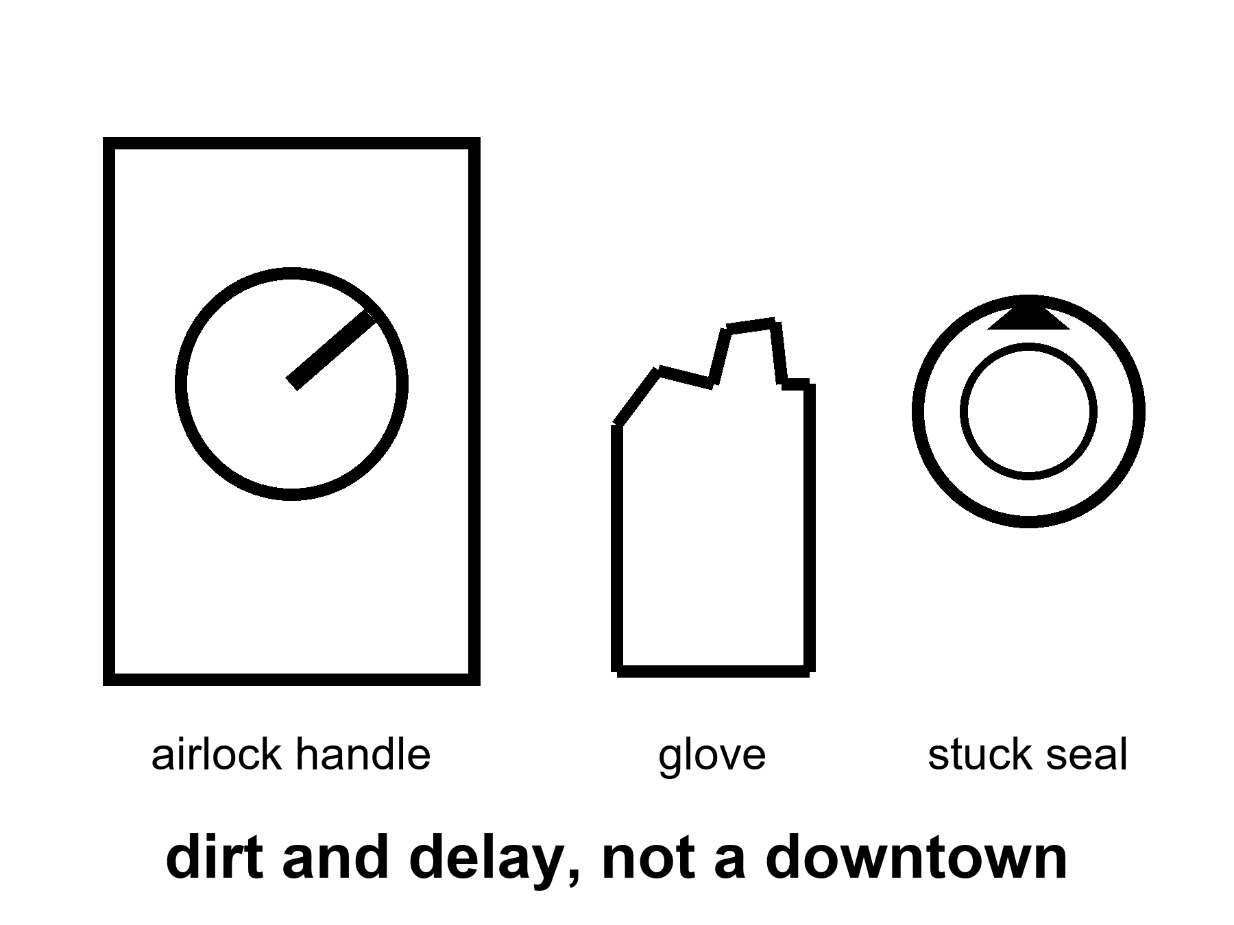
Figure 1. An airlock handle in hard daylight, a glove, a stuck seal. Dirt and delay, not a downtown.
This is the only honest picture of “somewhere else” this book will allow in the near term. A dead world, close enough that light-minutes, not light-years, set the lag. A body you can weigh. An ice vein you can steal. Machines that do not sleep parked in the driveway. A human worldline that has to eat. A date on a slide that will move.
She is not waiting for a miracle. She is waiting for a launch window. The next cheap path home — the one that lets a ship fall most of the way instead of burning a fortune — opens in twenty-six months, give or take the mood of the two orbits. Until then the potatoes either make starch or they do not. The universe does not have an opinion. The dirt has a chemistry, and the chemistry can be bullied.
This book is dirt, delay, and dates. It is not a loaf.
If you have Volume 1 of this series, you have already spent a long kitchen on a clock that pretended the universe shared a now. You do not need those pages. One courtesy, then we put the loaf down: elsewhere, in that book, was a permit — a band of starlight, a squeeze under ice, a chemistry that might copy — not a downtown as a product. This book is the permit after someone has printed a ticket. The ticket is real. The downtown is not on it.
If you have never met that book, you have not missed a homework assignment. You need three temperatures, a woman who logs pH, and a habit of not fusing three nouns. You have them by the end of Part I.
Every claim that matters wears a temperature.
Hot means established: measured, repeated, used to predict the next measurement. People and firms are spending real money on lunar crew systems, landers, and — on paper — surface camps. Uncrewed landers have already kissed dust in this century. Sample capsules have already come home. Light to the Moon takes about a second and a third. Light to Mars takes minutes. A cheap path between the two planets is a season, not a weekend. Most humans will stay on Earth for any leaving we can actually staff. A few thousand settlers do almost nothing to the air.
Warm means a working program with real gaps. A crew around the Moon this decade is a class of mission. The exact month is a mood. A landing attempt in the 2030s is the honest noun for a cabin that still owes the ugly parts: refuel, last kilometer, engines in a well, a suit you can work in and leave in. A heavy stack that becomes cheap per tonne if it learns routine would change the mass you can throw. Routine is the unpaid invoice. If industry collapsed, emissions would fall fast; so would the aerosol parasol. The infrastructure of going can worsen the bill for the people who stay.
Cold means a wish allowed by talk, not selected by the pieces we have already photographed working. A city on the Moon or Mars this decade. Children who do not need a cargo cult from Earth. Settlement as something you can buy by Friday because a founder named a year. Leaving as a cleanup. Earth bouncing back as a garden once the ambitious have gone.
A temperature can change. A stack that has flown is hotter than a rendering. A date that has slipped is not, by itself, a con, and it is not destiny. It is an invoice the slide did not want to show.
She is an invented person. The numbers around her are not invented.
A radio lag of four minutes, or twenty, is a fact about two orbits and the speed of light. It is not a metaphor for loneliness, though loneliness will use it. A pH log is a fact about a nutrient film and a plant that will die if the film goes wrong. A launch window of roughly twenty-six months is a fact about Earth and Mars lining up so a ship can fall most of the way. Appendix A1 writes the light-times and the window. Here, keep the stuck drawer.
Call her Mara if you need a name on a form. She will not use it much. The orbiter’s voice calls her by a shift number. The slide on Earth, if it mentions her at all, calls her a “surface asset,” which is a way to say a person without paying the person the courtesy of a Tuesday. She has a colleague on the other side of the tin, Rohan, who is better at the pumps and worse at the basil. She has a sister in a real kitchen, on a real coast, who still thinks “we” includes a ticket. The sister will not get a ticket. Almost no one will.
That is the first rude fact this book is here to keep in the room. A camp on a dead world is a staffing choice for a few thousand worldlines, maybe tens of thousands if the posters have a lucky decade. It is not a migration. It is a field trip that forgot to end. Chapter 13 is that sentence with the lights on. Chapter 1 is the picture you need before anyone is allowed to say we left.
Look first.
That rule, in the longer book, meant do not plague a dark sea because you were lonely for a cousin. Here it means two ruder things at once. Do not call a flag a biosphere. Do not treat the kitchen you already staff as a write-off because a dead world has been named a spare. Seed later is a rule for a sea that has never seen the Sun. It is also a rule for a biosphere you have not finished killing.
She hits the airlock again on the way out to the ice. The seal has a personality. Hardware that has a personality is hardware you can live with, if you stay honest about what it is. A seal is not a city. A greenhouse is not a school district. A slipped date on the radio is not a landing gear.
A word about mass, so the later chapters do not have to invent it.
Throwing a kilogram to low Earth orbit is a sport with a price that has come down in the lucky decades and is still not a bus ticket. Throwing that kilogram to the Moon is a ruder sport. Throwing it to Mars, and slowing it so it does not become a crater, is ruder still. The woman in the tin is a hundred kilograms of wet meaning plus a house that weighs tonnes. The house is the unpaid character in every downtown still. Posters draw faces. Programs are houses. Houses are mass, power, leaks, and a toilet that must work when the radio is twenty minutes late.
She has a spare pump on a shelf that came up on a cargo that cost more than her sister’s street will see in a year of municipal budgets. That sentence is not a reason to cancel the pump. It is a reason not to call the pump a species-move. The pump is a sortie tool. The street is the staff.
Appendix A1 writes delay, dirt, and why this kitchen is not a loaf. Here, keep the heel of the glove. The rest of the book is the argument that this is not small-mindedness. It is the only size a program has ever reliably sold.

2. A Program Is Not a Poster
A program is not a poster. That is the first temperature.
Hot: people and firms are spending real money to put crews around the Moon, to land on it, to throw a heavy stack that might, if it learns manners, throw more mass than the old horses. Uncrewed landers have already kissed dust in this century. Sample capsules have already come home. China has picked up far-side rock and talked, with partners, about a camp they name like a station. The American ledger has a name too, and a habit of printing a date that later needs a new page. The hardware is not a rumor. The downtown is.
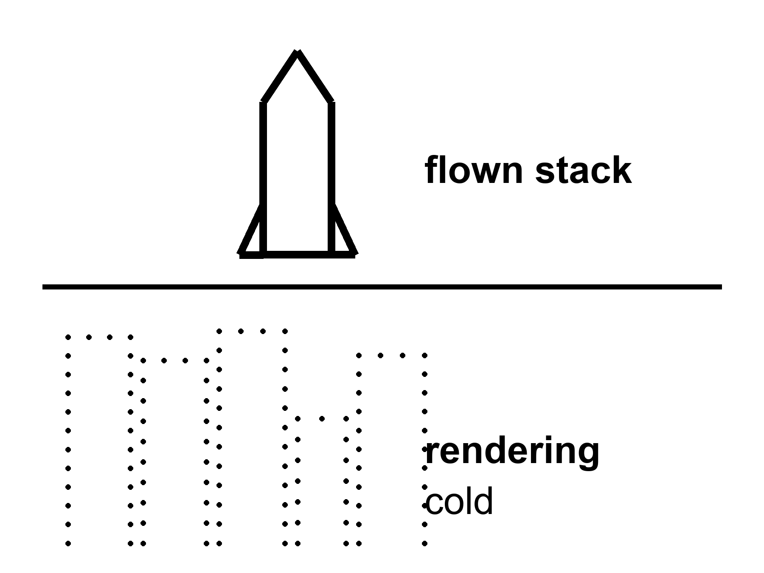
Figure 2. Two stacked panels: a flown stack on a pad in daylight; a skyline rendering. The first is inventory. The second is a wish.
A poster is a rendering of a downtown that has not yet hired a plumber. Glass, flags, a child who will never need a cargo ship, a dome that has already solved dust, radiation, law, and boredom. Posters are allowed. They are how a legislature is asked for money and how a founder is asked for a valuation. They are not inventory. Treating them as inventory is how a flyby becomes a school district in a single slide.
A program is uglier and better. It is a stack that has a serial number. It is a heat shield with a scorch from a test that did not kill anyone, or did. It is a suit whose gloves still fight you. It is a budget line that can be raided when a different emergency is louder. It is a weld, a software load, a supplier who missed a month, a review board that found a crack and did not pretend the crack was a vibe.
Elena Voss runs reviews for a living. She is invented. The room she sits in is not. Fluorescent light, a table that has heard too many dates, a wall with a patch that used to be last year’s milestone and is now this year’s “replan.” She has a rule she does not write on the slides: if it has not flown, it is a story with a purchase order. If it has flown once, it is a dare. If it has flown until the news stopped covering it, it is beginning to be a truck.
Most of what the public is shown is still a story with a purchase order.
What counts as flown?
A Saturn-class stack that put people on the Moon and brought them home is flown. That is last century, and it is still the only time flesh walked on another world and returned. It was a sortie. It was not a town. The last person to leave that dust left in 1972. The posters did not stop. The shifts did.
An uncrewed loop around the Moon that comes home without a crew is flown if the stack, the heat shield, and the entry were the ones you said you would use. Artemis I, in late 2022, was that kind of morning: a cabin without people, a long cold loop, a splashdown that let a lot of engineers sleep. Hot as a class. Not a town. Not even a sortie. A dress rehearsal that cost what dress rehearsals cost.
A lander that kisses dust and phones home is flown. Some of this century’s kisses have been tidy. Some have been a tip-over, a lost solar panel, a hard landing that still counts as “arrived” if you are generous and “failed” if you are the person who needed the payload. Chang’e-class sample returns — near side, then far side — brought rock to a desert in China and put it in a box you can weigh. That is flown. Chandrayaan-3 put a lander and a rover on the southern near side and drove. That is flown. Commercial landers have begun to try the same dirt with mixed manners. Mixed manners are data. They are not a downtown.
A heavy stack that has lit, flown, and come back in some pieces, some of the time, is flown as a vehicle in progress. It is not flown as a city. Chapter 10 is that distinction with the tanks on the table. Here, notice that a successful hop, or a noisy orbital test, or a catch that makes a clip, is still a vehicle fact. A vehicle fact is allowed to be exciting. It is not allowed to launder a school district.
Gateway, on paper, is a station in a odd lunar orbit. On the floor, as of this kitchen, it is modules, contracts, and a fight about whether you need the station to do the landing. A module in a clean room is hotter than a rendering. A module on the Moon’s doorstep is hotter still. A downtown is still cold.
The laundering has a few favorite costumes.
The artist’s cut. A glass dome, a flag, a child. The caption says 2035 the way a restaurant says seasonal. Seasonal means the chef has not decided. 2035, on a poster, often means the same.
The year-as-landing-gear. A founder names a year. The year is treated as a demonstration, as if saying it tightened a bolt. Years do not tighten bolts. Years are a mood the slide is in.
The flag-as-shift. Someone has been there; therefore someone lives there. Apollo is the permanent victim of this costume. Twelve men walked. They left. The walk was a masterpiece of a certain kind of engineering. It was not a lease.
The stack-as-city. A ship is large. A large ship looks like a building. A building looks like a town. The eye does the fusion. The eye is wrong. A ship is a vehicle. A vehicle that is also a house for six months is still a vehicle. Chapter 12 will give you three nouns and refuse to let them marry.
Elena’s meeting has a fourth costume, quieter and ruder: the budget-as-destiny. Money is being spent; therefore the downtown is selected. Money is a temperature, not a destination. Money has been spent on flying cars, on a permanent Moon base in every decade since the 1960s, on a Mars mission “in this decade” so many times the phrase has a patina. Spending is hot. Arrival is a different measurement.
She hears the poster on the delay. Someone has sent a still of a dome that does not exist, over a horizon she can see by walking to the inner pane. The horizon is dust and a pump that needs a bearing. The dome is a kindness the slide is doing to itself. She logs the pH. The basil does not care which logo paid for the LED.
A program can be proud of what it has actually flown and still be allowed to want more. This book is not a counsel against wanting. It is a counsel against inventory fraud. If you remember one sentence from this chapter, make it the title. A program is not a poster. The rest of the book is what happens when people sell you the second and bill you as if you bought the first.
Appendix A2 writes a short ledger of what has actually flown in this century — loops, landers, samples — and what has not. Here, keep the two panels. The pad is inventory. The skyline is a wish.

3. How Dates Slip
Hot as a pattern: dates slip.
Heat shields, suits, refueling, politics, a weld, a budget. A slip is not destiny. It is not, by itself, a con. It is an invoice the slide did not want to show.
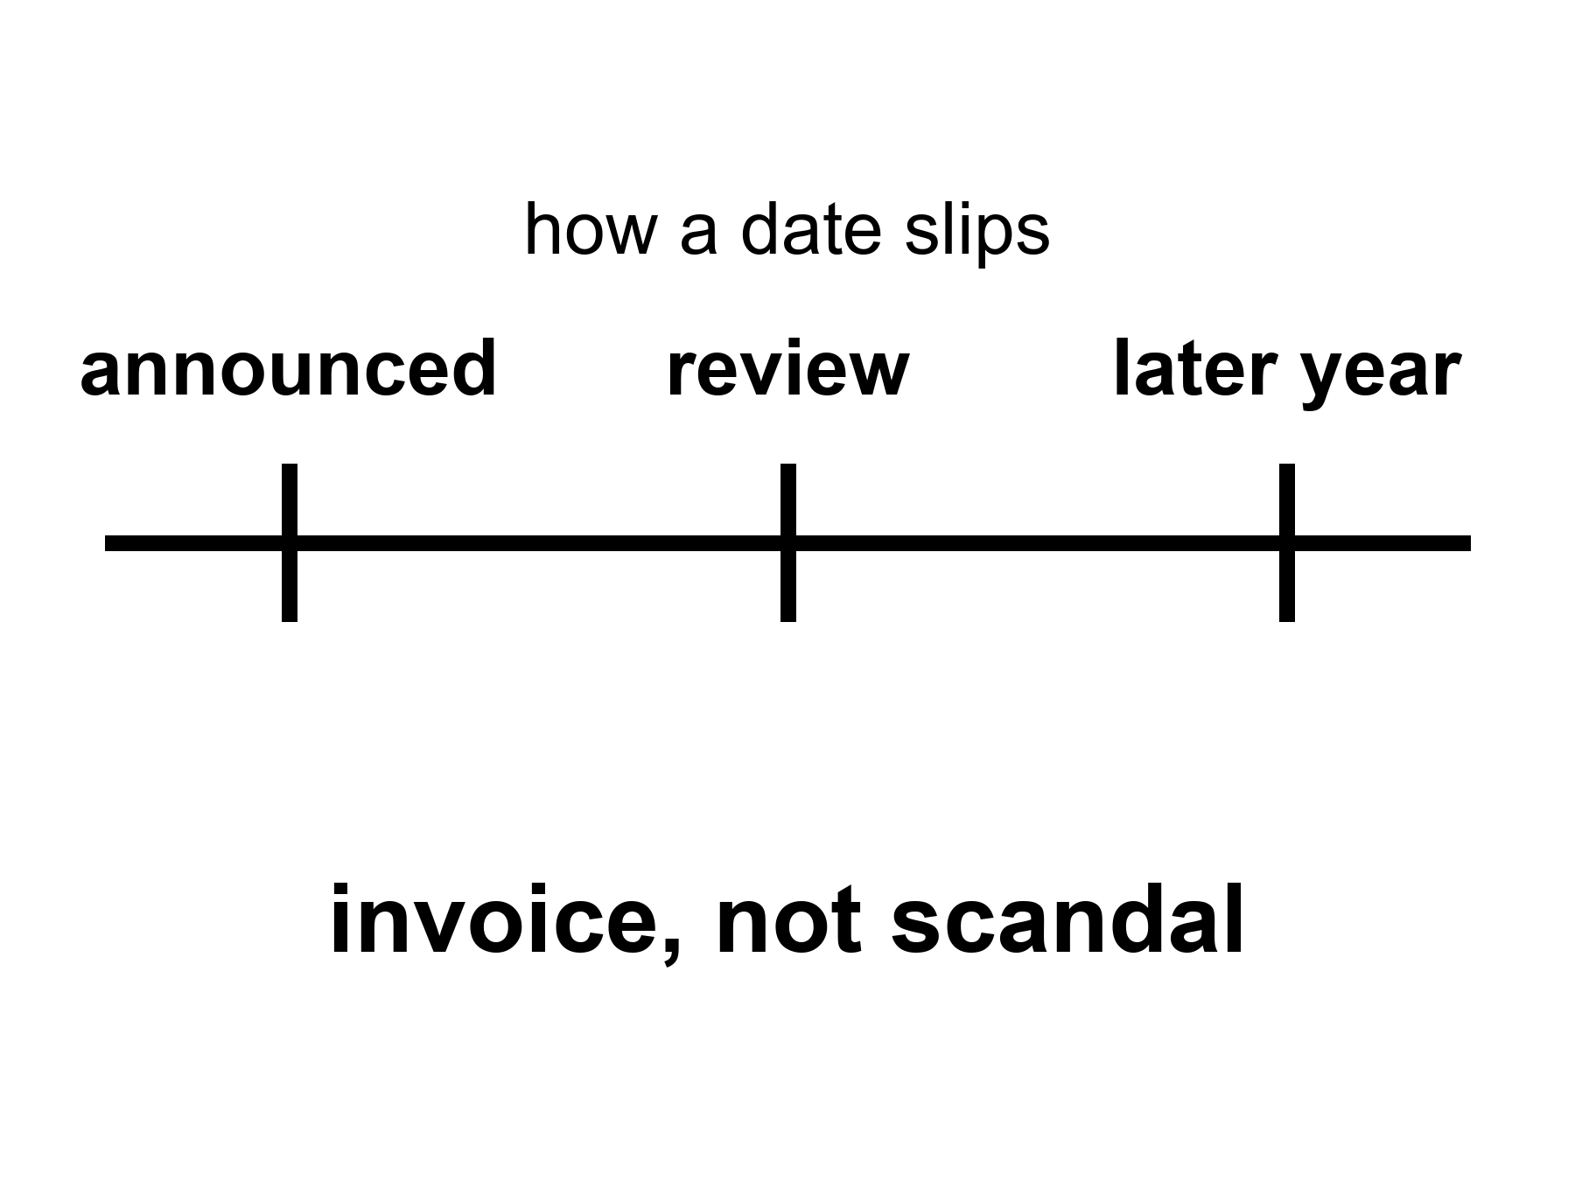
Figure 3. One horizontal line, three large ticks: announced year, review, later year. The label is invoice, not scandal.
The radio is late, as always. On the good weeks it is four minutes. On the rude weeks it is twenty. Someone on Earth is still selling a year as if a year were a landing gear. The year in this morning’s packet is not the year in last year’s packet. Mara does not gasp. She has been in this kitchen long enough to treat a date as a weather report: useful, local, wrong tomorrow.
Official slips are engineering plus politics. Both words have to sit still.
where a slip is a moved official date for a named class of mission — not a mood, not a conspiracy proof, not a destiny.
Engineering is the part the posters skip because it is a list. A heat shield that charred too deep. A valve that iced. A suit whose bearings seize in dust that has no water to be polite. A refueling rehearsal that leaked, or did not light, or lit and then taught you a new way to be afraid. Software that raced a race it was not supposed to win. A supplier that could not find a forging. Radiation that a paper said was fine and a phantom that a crew doctor will not sign. None of these is a morality play. Each is a thing that takes calendar.
Politics is the other half of the same invoice. A legislature that wanted a landing in a term it could campaign on. A new administrator who inherited a stack and a story and changed the story. A partner nation that delayed a module. A contractor who bid a number that was a wish. A war, a pandemic, a different agency’s emergency, a launch that failed two pads over and made every review board sit up. None of these is proof that the Moon is a hoax. None of these is proof that the downtown is inevitable “once they stop lying.” They are how a species that does projects with other people actually does projects.
The two halves talk. A technical delay becomes a budget fight. A budget fight becomes a technical delay, because people leave and drawings freeze and a test stand sits idle. Treating the pair as a scandal is a way to keep the slide innocent. Treating the pair as destiny — it always slips, therefore it never happens — is the other innocence. Things that slipped have also flown. Apollo slipped and then walked. Shuttle slipped and then flew, and then taught a ruder lesson about wishing a date harder than a tile. Artemis-class dates have slipped in public, more than once, in the decade that leads into this kitchen. The slipping is the pattern. The walking is still a warm class of mission, not a cancelled species of event.
Tom Brennan writes dates for a living. He is invented. His job is real and has a nicer name on the org chart. He sits in Elena’s reviews with a spreadsheet that has three columns: announced, internal, what I would bet. He is not allowed to show the third column. The third column is why he still has a conscience.
He has watched a year move the way a casserole estimate moves when you open the oven and the middle is still soup. The honest sentence is: we opened the oven. The slide’s sentence is: the dinner is still at eight, we have redefined eight. Both can be said without fraud. Fraud begins when the oven is empty and the slide still has a roast.
How do you tell an invoice from a con?
A con hides the oven. It will not show the heat-shield coupon, the suit’s dust trial, the refueling attempt, the missed weld. It updates the year and updates the rendering and calls the pair “on track.”
An invoice shows the coupon. It says: this part failed, this is the retest, this is the new earliest morning that is not a wish. It may still be optimistic. Optimism is not a crime. Optimism plus a locked press kit plus a punishment for the person who reports the coupon — that is how invoices go bad.
This book will not run a courtroom for any one logo. Logos change. The pattern does not. If you want a morality play, write a different book. If you want to know how soon, learn to read a slip as information. A slip that names the long pole — the lander has not demonstrated the last kilometer; the suits are late; the tanker has not transferred — is a gift. A slip that names only “integration” is a fog. Fog is not fraud. Fog is what a program sounds like when it has not yet chosen which invoice to show.
A date is a kind of clock. It is not the only kind.
The Moon is three days away at the speeds we actually use, and a second and a third at the speed of light. Those clocks do not slip when a review board meets. Mars is minutes away by radio and a season away by a cheap path, and twenty-six months away by the next cheap path if you miss this one. Those clocks do not slip either. They are orbits. Orbits are rude and fair.
The clocks that slip are the human ones: when a stack is ready, when a suit is wearable, when a tanker can pour, when a legislature will pay, when a partner will deliver a can. Confusing the two families is how a founder’s year becomes a landing gear. The orbits do not care about the founder. The founder can still be useful. Usefulness is not a demonstration of a downtown.
She hears the new year on the delay. She writes it in the log under Earth says, next to the pH, which is a number the dirt actually offered. She does not vote for the year. She votes for the seal on the airlock, which is either going to sigh or not.
A crew around the Moon this decade remains warm as a class. The exact month remains a mood. A landing attempt in the 2030s remains warm as a class. A city this decade remains cold. None of those temperatures is a function of how loudly someone is disappointed. Disappointment is not a thermometer.
A pattern-book, so the next chapters do not have to re-teach the oven.
Apollo announced mornings that moved, then walked. The walk did not make the slips imaginary, and the slips did not make the walk a con. Shuttle announced a truck and delivered a thoroughbred that flew, killed, flew again, and taught a civilization that wishing a date harder than a tile is a way to hold a funeral. Constellation printed a return to the Moon and was cancelled as a program. Cancellation is not a proof that the Moon is unreachable. It is a proof that a ledger can fire a floor plan. Artemis-class crew dates have moved in public, more than once, in the decade that leads into this kitchen. A commercial heavy stack has moved in public, more than once, for the same reasons a casserole moves: the middle was soup when the oven was opened.
Tom keeps a fourth column he does not show: what would have to be true for the announced year to be a landing gear. Suits wearable in dust. A pour that has manners. A shield that has a coupon. A partner can that has left a factory. A legislature that has not raided the line. If three of five are stories, the year is a mood. If four of five have serial numbers, the year is still allowed to slip, because the fifth can still be a weld.
Mara’s log has a page for Earth says and a page for dirt says. The first page is crowded. The second page has pH, ice mass, a bearing temperature, a seal that sighed or did not. She trusts the second page. She reads the first so she knows what the radio will ask her to celebrate.
Appendix A3 writes a short pattern-book of public slips — Apollo, Shuttle, Constellation, Artemis-class, a commercial heavy stack — without turning any line into a sermon. Here, keep the three ticks. Announced. Review. Later. The space between them is where the work lives. The work is allowed to be slow. The slide is not allowed to call the slowness a landing.

PART II — The Moon First

4. The Moon First, Because It Is Close
The Moon is first because it is close. That sentence is allowed to be boring. Boring is how you do not die of a poster.
Three days, not months. A second and a third for the radio, not four minutes, not twenty. One-sixth of the weight you grew up in, which is a kindness to the legs and a rudeness to the dust: everything you kick stays in the conversation longer than you wanted. A test kitchen, not a spare Earth.
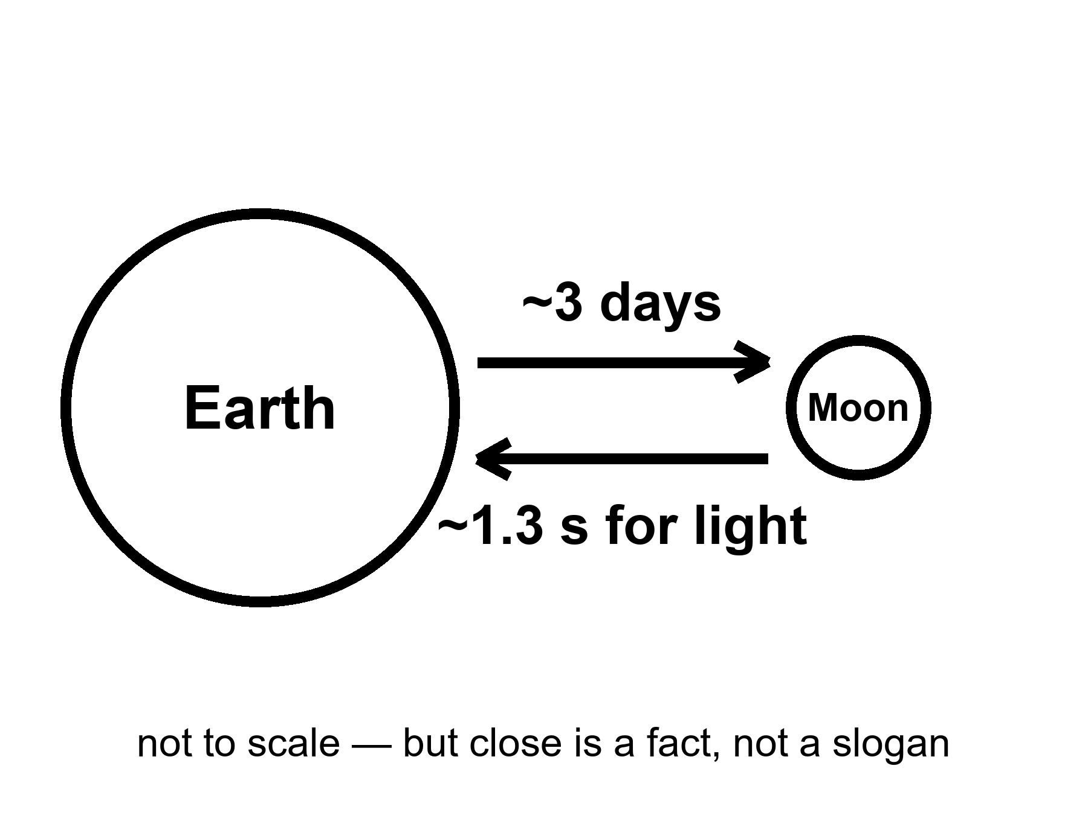
Figure 4. Earth and Moon on a simple line; a three-day tick, a 1.3-second tick. Close is a clock, not a romance.
where light-time to the Moon is about 1.3 seconds one way — a delay you can talk through, if you are patient, and still call a conversation.
Mars will not give you that. Mars gives you a monologue with a pause that can eat a lunch. The Moon gives you a slightly drunk phone call. That difference is not poetry. It is why a medical emergency, a jammed airlock, a software load that needs a human who is still on Earth, is a different sport at three days than at a season.
The cheap path to the Moon is not a Hohmann argument with a twenty-six-month sulk. You wait for a monthly-ish window, you light, you coast a few days, you arrive in a gravity well that is shallow compared with home and still perfectly able to kill you if you arrive wrong. Abort, in many of the early hours, still means fall back to Earth with a heat shield and a prayer that is really a number. Abort from a Mars transfer, once you are weeks in, is a different novel. Chapter 11 writes that novel. This chapter writes the reason the novel is not the first homework.
Close is not kind. Close is reachable.
The Moon has no air you can hire. It has a vacuum that will boil your spit and a dust that is glass, not potting soil. The dust is electrostatic, sharp, and in love with seals. It will find the airlock that already sticks. It will find the pump. It will find the lung if you let it. The temperature swings like a door left open on a winter night and a summer noon, because there is no blanket of air to argue with the Sun. Two weeks of day, two weeks of night, if you sit on the equator like a tourist. The poles, which the current posters love, have a different kitchen: low Sun, long shadows, craters that have not seen light since before anyone named a king, ice in the dark if the maps are right, and a power problem the moment the Sun sits on the horizon like a stingy coin.
Ice at the poles is the sentence that turned the Moon from a flag stand into a maybe-kitchen. If the ice is there in useful amounts, and if you can mine it without spending more water than you gain, you have propellant and drink and air, in principle. In principle is not a tank farm. ISRU — in-situ resource utilization, the kitchen word for make it there — is the middle noun trying to become the third. Papers and prototypes exist. A city does not.
One-sixth g is a playground and a clinic. Bones and legs that spent a career under Earth will not thank you for a long stay unless you work them. Fluids shift. Dust hangs. A fall is slower and still a fall. The playground photographs well. The clinic is why a winter-over is a medical program, not a camping trip.
Radiation is the unpaid guest. The Moon has no magnetic kindness worth mentioning and no air to spend the first of the particles. A solar storm can arrive as a homework assignment you fail with your bone marrow. A habitat is a pile of dirt, or water, or regolith bags, or a lava tube if you are lucky and the tube is not a fairy tale for your latitude. Apollo stayed a few days and came home. A few days is a sortie. Months is a different dosimeter.
Why first, then, if it is a vacuum with a dust problem?
Because every ugly part of going somewhere else is cheaper to learn three days away than a season away. Landing. Leaving. Suits. Dust. Power through a night. A radio that is almost a conversation. A missed landing that is still a missed landing, but the inquiry can have the people in the same room as the families within a week. A test kitchen is where you burn the first loaf. You do not rent a hall for a wedding and then learn to bake.
The Moon is not a spare Earth. It will not take the species if the kitchen at home fails. It has no biosphere to recover, no forest to grow back, no grandmother of a bird to un-extinct. It is a rock with a useful well, a useful ice rumor, and a useful closeness. Calling it a spare is how you stop washing the one you have. Chapter 15 is that sermon’s funeral. Here, keep the three days.
Mara is not on the Moon. She is on the ruder neighbor, or on a thought-experiment that wears the neighbor’s butterscotch sky. The book keeps her there so the delay stays honest. The Moon would have given her a radio that almost answered. She would still have logged the pH. The basil would still not have cared about the logo. Close does not make a downtown. Close makes a classroom.
A note on “why not Mars first,” because the posters ask it with a straight face.
Mars has days that last about a day, a little carbon dioxide you can point a box at, ice at the poles and in the dirt, and a romance that photographs in butterscotch. The Moon has none of that romance and a radio you can almost use. The first kitchen you burn a loaf in should be the one you can phone from, and abort from, and hold an inquiry in without a twenty-six-month sulk. That is not timidity. That is how you do not spend a crew on a first lesson that could have been a third-day lesson. If a later decade makes Mars a sortie, it will still have been cheaper that the suits, the dust, the leave, and the habit of not fusing nouns were learned on the close rock.
Appendix A4 writes the 1.3 seconds, the three days, the one-sixth, a sketch of lunar Δv, and why polar ice is a maybe-tank, not a city charter. Here, keep the line with two ticks. Close is a clock. Romance can sit in the hall.

5. What Has Already Flown
Uncrewed loops, landers, sample returns. A flag is not a shift. A kiss of dust is not a lease.
Hot: this century has already put machines on the Moon, driven them, failed in public, succeeded in public, and brought rock home from both the familiar face and the face we used to call the back. That sentence should be taught before any founder’s year. The hardware is not a rumor. The downtown is.
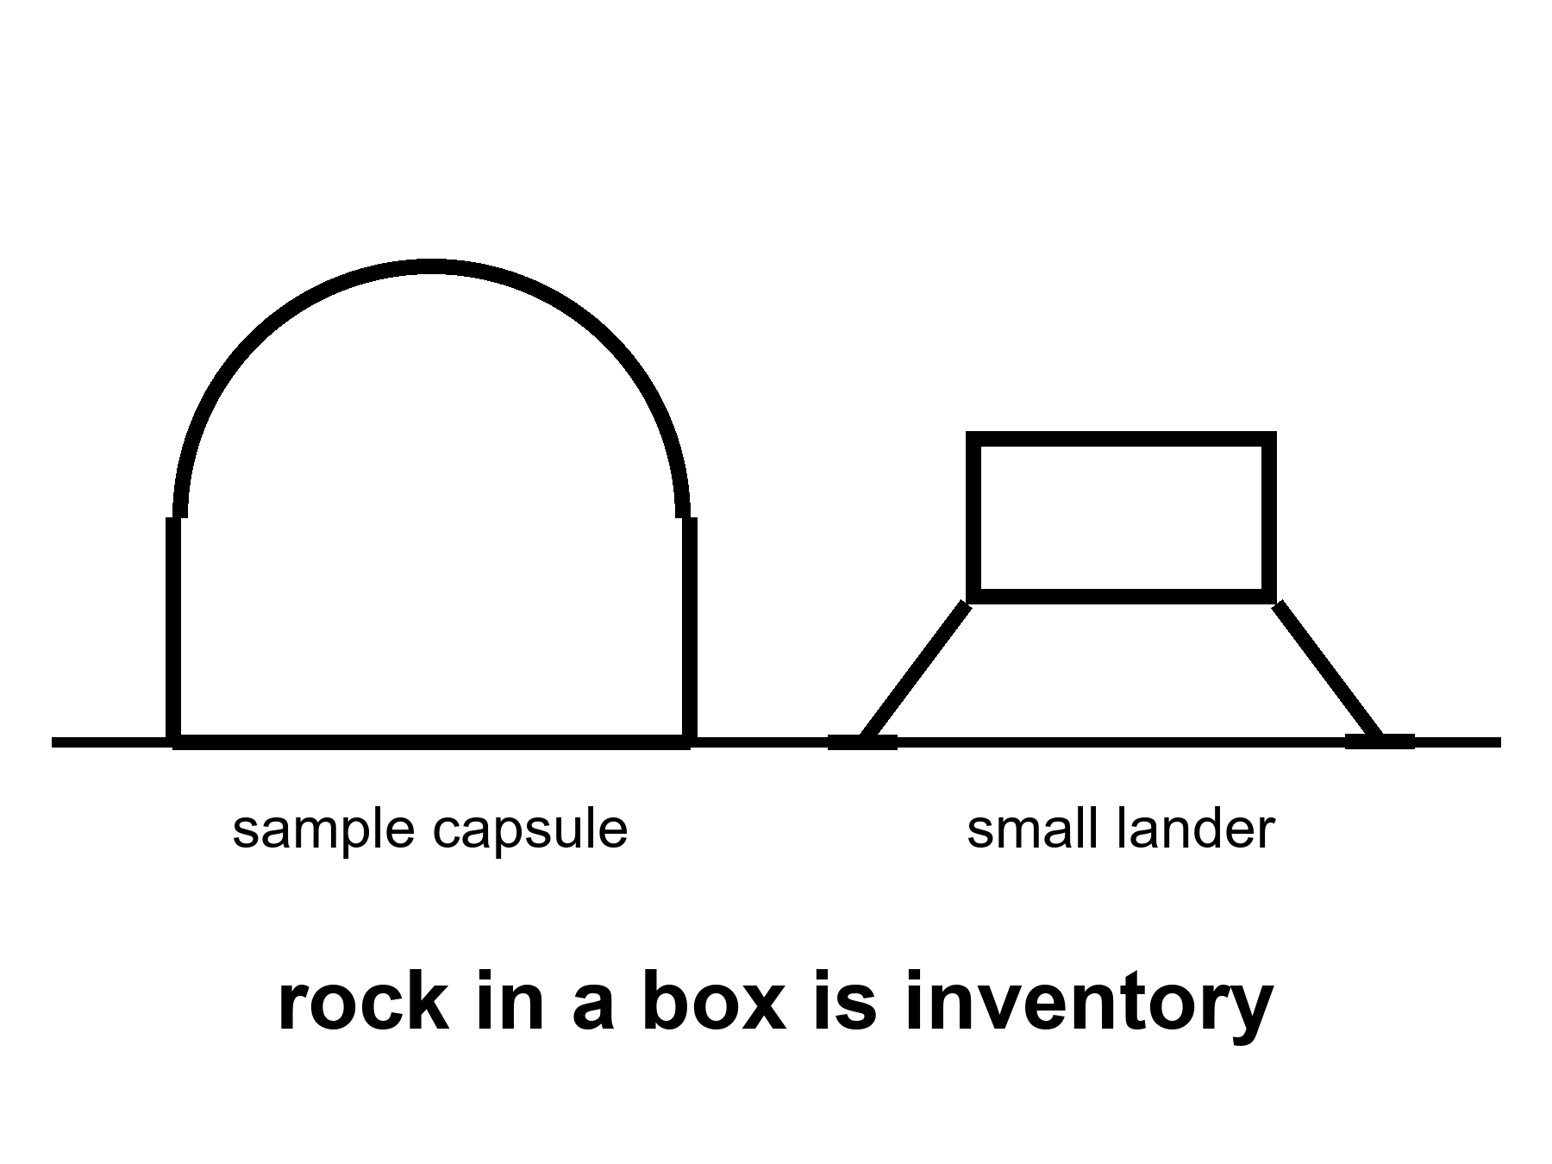
Figure 5. A sample capsule and a small lander, both large in frame, on bright ground. Rock in a box is inventory. A skyline is not.
Start with the loops, because a loop is the dress rehearsal people skip when they are in a hurry to walk.
A cabin that flies a long cold path around the Moon and comes home without a crew is a test of stack, shield, software, and the habit of hitting the thin air of Earth at a speed that will kill you if the shield is a story. Artemis I did that in 2022. Other nations have sent uncrewed craft on lunar paths for decades. The new fact is not that a loop is possible. The new fact is that a crew-shaped cabin, on a stack meant to carry people later, has done the loop and splashed. Warm as a step. Hot as a class of thing that has now happened. Not a sortie. The seats were empty on purpose.
Landers are ruder than loops. Loops do not have to negotiate the last kilometer of a well with no air to help you regret. The last kilometer is a sport. Some of this century’s landers have been tidy: Chang’e-class craft that set down, deployed rovers, and, in the sample-return editions, threw a bit of the Moon into a can and sent the can to a desert you can drive to. Chang’e-5 brought near-side rock home in 2020. Chang’e-6 brought far-side rock home in 2024. Those are flown facts. They are not shifts. No one stayed. The rock is in a box. The box is hotter than a rendering of a dome.
Chandrayaan-3 landed near the south in 2023 and drove a rover. Japan’s SLIM arrived with a precision dare and a landing that taught a lesson about ending up on your head and still phoning home. Commercial landers — an American class that wants to be a truck service — have begun to try the same dirt. Some have stood. Some have tipped, leaked, or gone quiet. Mixed manners are what a new truck service looks like. They are not a proof that “the Moon is open for business” in the sense a Chamber of Commerce means business. They are a proof that kissing dust is no longer a national once-a-decade miracle. It is becoming a thing companies fail at in public. Failure in public is how trucks get better. It is not a town.
A sample return is a special kind of flown.
You must land, or at least collect. You must launch again from a well, or throw the can to a waiting orbiter. You must hit Earth’s air and not cook the rock. You must find the can. The rock, once you have it, is a library: isotopes, water histories, a date, a fight about whether the poles are a tank farm. Chang’e-class returns are the modern masters of this sport. Apollo brought more mass, and also people, and also a flag. Apollo is last century. This century’s returns are robots. Robots are the honest near-term staff. Chapter 31 of the longer book already said a crew that does not sleep can wait. This book says a crew that does not sleep can also fetch a box so a person in a desert can open it.
What has not flown, while we are cleaning the inventory:
A crew around the Moon in this century, as of this kitchen. That is still a warm class, not a photograph.
A crew landing in this century. Warm as an attempt in the 2030s. Not flown.
A winter-over. Not flown.
A tank farm of lunar ice turned into a tanker of oxygen. Not flown. A small experiment that makes a breath of oxygen from lunar dirt or from a box of regolith in a lab is a paper and a prototype. Keep it warm as a class of trick. Do not cash it as a city.
A child. A school. A law court. A farm that feeds a town without a cargo cult. Cold. Not flown. Not scheduled as a product this decade.
Rohan, on the other side of Mara’s tin, used to work payloads. He is invented. He still flinches when a slide shows a flag and a skyline in the same frame. He has opened boxes that came from space and found, inside, a gram of something that cost a career. He respects the gram. He will not let the gram rent a halo.
A flag is a photograph of a sortie that ended. A shift is a roster that repeats, a pump that has a spare, a person who is replaced when the person is spent. The Moon has had flags. It has not had shifts. This century’s robots are the beginning of a shift for machines. A machine shift is not a town. It is how you learn the dirt before you ask a body to log the pH for a year.
She hears, on the delay, that another lander has tipped. Someone on Earth is already writing the sentence that the tipped lander means the program is a con, or the sentence that the tipped lander means the downtown is one failure closer to being inevitable. Both sentences are costumes. The tipped lander means the last kilometer is still a sport. She logs the pH. The basil does not require a flag.
Appendix A5 writes a ledger of this century’s loops, landers, and returns — successes, tip-overs, boxes in deserts — without turning any logo into a hero. Here, keep the capsule in the frame. Rock in a box is inventory. A skyline is not.

6. The Next Crew Around the Moon
Warm: a crew around the Moon this decade — a flyby, a cabin, a look at a dead close world that is three days away, not three seasons. Call it an Artemis-II-class morning. The exact month is a mood. The class is the fact: flesh, cis-lunar, home in a week if the stack behaves. That is a sortie. It is not a town.
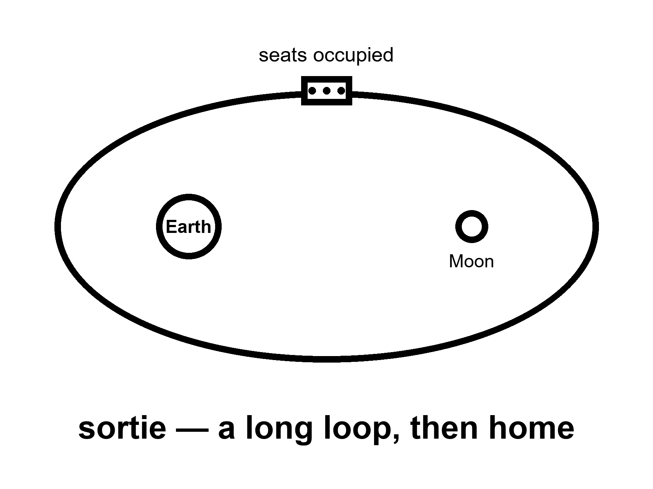
Figure 6. A cabin on a long loop, Earth and Moon both small. Seats occupied. No dome.
The seats, this time, are not empty on purpose. That is the whole increment. Four bodies, or a number like four, in a cabin that has already flown empty. They will see the Moon as a disk that grows, then as a wall, then as a disk that shrinks. They will not land. They will not log a pH on the dirt. They will test the life-support the empty cabin could not confess: the smell, the CO₂, the toilet, the tempers, the suit drill that is a pantomime of a later morning. They will come home, if the shield and the numbers hold, and they will be called pioneers, which is a kindness, and a crew on a sortie, which is the noun.
A flyby is a crew sortie. It is not a town.
Keep the nouns unfused even here, before Chapter 12 makes a courtroom of them. The people in the cabin go, they work, they come home, or they die on a schedule Earth still owns. That is the first noun. The slide will try to marry it to the third. Refuse the marriage. A photograph of four faces in a window with the Moon in it is a masterpiece of a certain kind of engineering. It is also a week. A week is not a school district.
Why does the month stay a mood?
Because the stack that throws the cabin is a machine with a temper, and the cabin is a machine with a temper, and the two must agree, and the abort modes must be more than a slide, and the suits — even if they are not walking — must not be a rumor, and the weather in the political kitchen must hold long enough for a count-up. This kitchen is dated September 2026. Official pages have named years that later needed a new page. By the time you read this, the morning may have happened, or slipped, or slipped again. The class does not care. The class is: flesh, around the Moon, home in days, this decade as a warm bet, not as a prophecy.
If the morning has already happened when you open these pages, the chapter is not wasted. You now own a flown sortie. You still do not own a town. The temptation will be to treat the splashdown as a lease. It is a splashdown.
If the morning has not happened, you still own the empty-cabin loop, the landers, the boxes of rock. You own a warm class. You do not own a fraud just because a date moved. Chapter 3 already billed that invoice.
Jules Adeyemi is the invented name on a crew-shaped roster. He runs, in this story, the kind of checklist that makes a cabin less likely to kill you with a valve. He does not think of himself as a founder of a city. He thinks of himself as a person who will be very far from a hospital and very close to a heat shield. That is the correct self-portrait. The poster will paint a different one. The poster is not invited on the stack.
What the sortie is for, if you want a purpose that is not a sermon: to make the next landing attempt less of a first time. Life support with breath in it. Navigation with a crew that can be sick. A communications stack that has to carry a voice, not a beep. A public that has to remember that spaceflight is a sport in which the ball can kill you. Those are program reasons. They are enough. They do not require a downtown on the far side of the loop.
Mara hears the crew on a relay that is not for her. Someone reads a name. Someone reads a slipped date for a later landing that the flyby was supposed to make inevitable. Inevitable is not a temperature we use. She logs the pH. The basil is a little too alkaline. That is a problem she can bully. A town on the Moon is not.
Appendix A6 writes what an Artemis-II-class morning has to demonstrate and what it is not asked to demonstrate. Here, keep the cabin on the loop. Seats occupied. No dome.

7. A Landable Year Is Not a Town
Warm: a landing attempt in the 2030s — a cabin that goes down and is supposed to come up, a lander that still owes a demonstration of the ugly parts: refuel in orbit, survive the last kilometer, light the engines in a gravity well with no atmosphere to help you regret. HLS, Starship-class, whatever logo wins the week. “Attempt” is the honest noun. A flag is not a greenhouse. A greenhouse is not a school district.
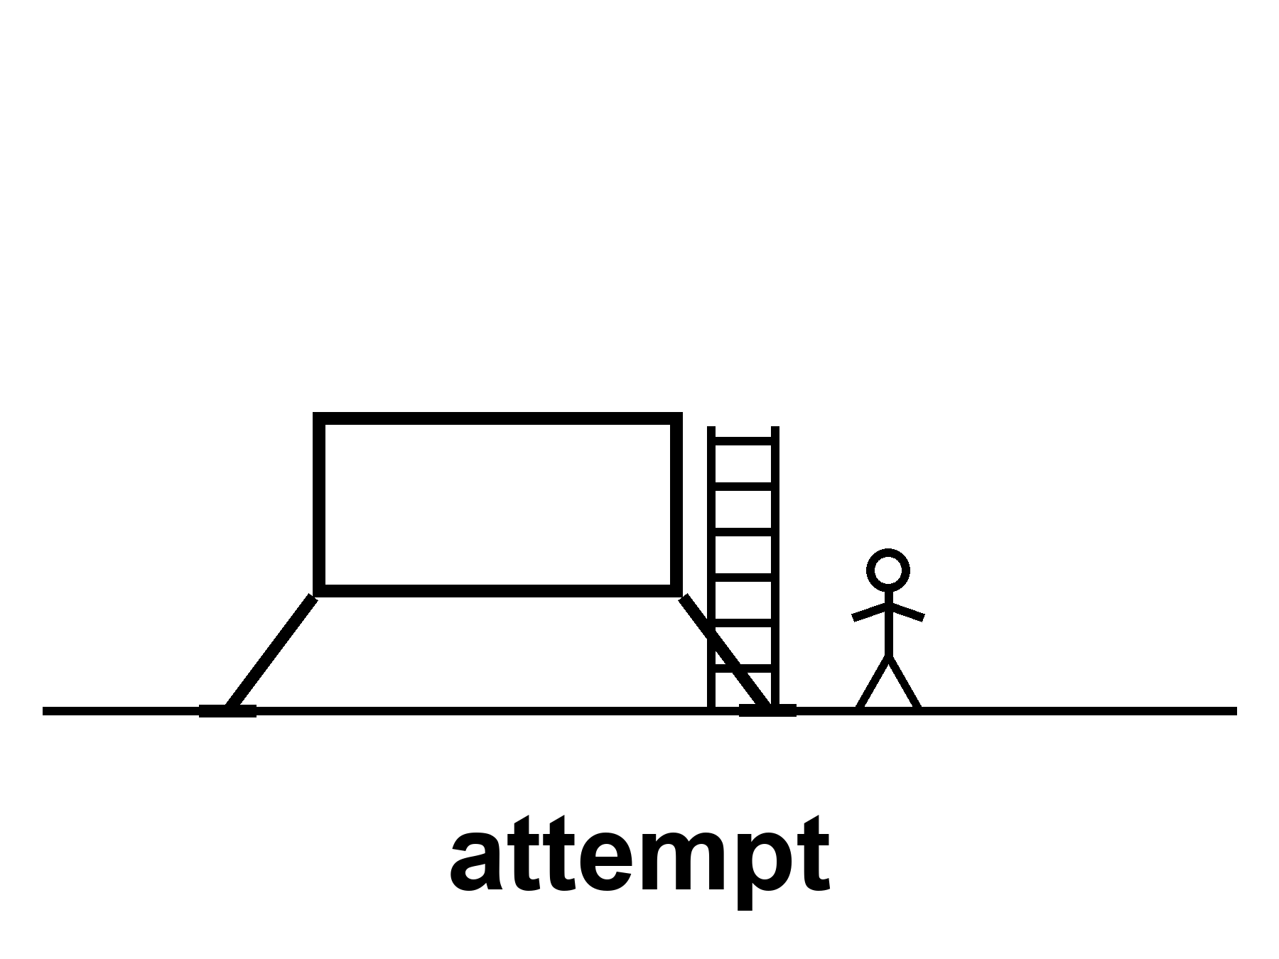
Figure 7. A lander on bright dirt, one figure, a ladder. The caption: attempt. No skyline.
The long poles have names. They do not have a single year that is a landing gear.
Refuel. If the lander is a heavy stack that arrives in pieces, someone must pour propellant in orbit the way you pour a second pot of coffee: many times, without making a bomb. That pour has been a paper, a test, a hope, a clip. Routine pours are the unpaid invoice. One pour is a dare. A campaign of pours is a trucking company. Chapter 10 is the trucking company. Here, notice that a landing architecture that requires the pour cannot honestly print a month before the pour has manners.
The last kilometer. No air to bite. Engines that must throttle or stage or both. Dust that will sandblast the vehicle you need to leave in. A slope that was a pixel on a map and is a decision at ten meters. Abort, this close, is a different novel than abort on the way out from Earth.
Leave. The part the flag photographs skip. You must light again, from a well, with a vehicle that has sat in dust and cold and a night, and you must meet the cabin that will take you home, or be the cabin that will take you home. Apollo’s leave was a small, fierce, already-demonstrated trick by the time the public saw the flag. A new heavy lander’s leave is a new trick until it is not.
Suits. You must walk, bend, see, pick up, not cook, not freeze, not fill the bearings with glass dust, and get back in. A suit is a spacecraft you wear. Spacecraft slip. The glove is a workplace. The workplace has not yet done a shift on this dirt in this century.
The rest of the house. Power through a polar night or a polar “day” that is a long dusk. Navigation without a kindly GPS constellation, unless you brought one. A habitat that is the lander itself, or a can you sent ahead, or a tin that has not flown. Medical. Waste. The pH of something you are trying to grow, if you are arrogant enough to grow. Arrogance is allowed in a test kitchen. It is not a town charter.
“Attempt” is the word that keeps the temperature honest.
A program that says we will land in year X is printing a mood. A program that says we will attempt a landing in this class of years, once these poles are paid is printing an invoice. The second sentence can still be wrong. It cannot be as wrong as a downtown.
If the attempt happens and the crew walks and comes home, you have a flown sortie on dirt. Hot, the morning after, as a class of event that has rejoined the inventory. Still not a town. Apollo already taught this, and the century forgot it on purpose because forgetting is how you sell the next slide.
If the attempt happens and fails, you have a funeral or a miracle of abort, and a review, and a slip. The slip will be called a scandal by people who needed the downtown for a feeling, and a destiny by people who needed the failure for a feeling. Chapter 3 already refused both feelings as thermometers.
If the attempt has not happened when you read this, you are in the same kitchen this chapter was written in. The poles are still the poles. The year is still a mood.
Linh Pham designs suit gloves. She is invented. The dust is not. She has a box of lunar simulant that is not the Moon and is still rude to bearings. She can tell you, at a table, why a glove that works in a clean room fails after an hour of glass. She is the long pole that photographs badly. The poster wants a face in a gold visor. The visor is easy. The glove is the town, if there is ever a town: a person who can work. Work is not a flag. Work is a shift.
Mara’s airlock is a glove problem in a different gravity. She hits it. She thinks of Linh, whom she has never met, and of a year on a slide, which she has met too often. She logs the pH. The landing year, if it arrives, will not water the basil.
Appendix A7 writes the long poles — refuel, last kilometer, leave, suits — as a list you can keep when the logo changes. Here, keep the ladder and the word attempt. A landable year is not a town.

8. Gateway and the Architecture Fights
A station in lunar orbit is a choice, not a law. Camps have floor plans that change.
Warm-to-cold: a winter-over. Months. Cargo from Earth. A Gateway or a surface tin that changes drawings because architecture is a fight, not a destiny. The fight is allowed. Treating the current drawing as a city charter is not.
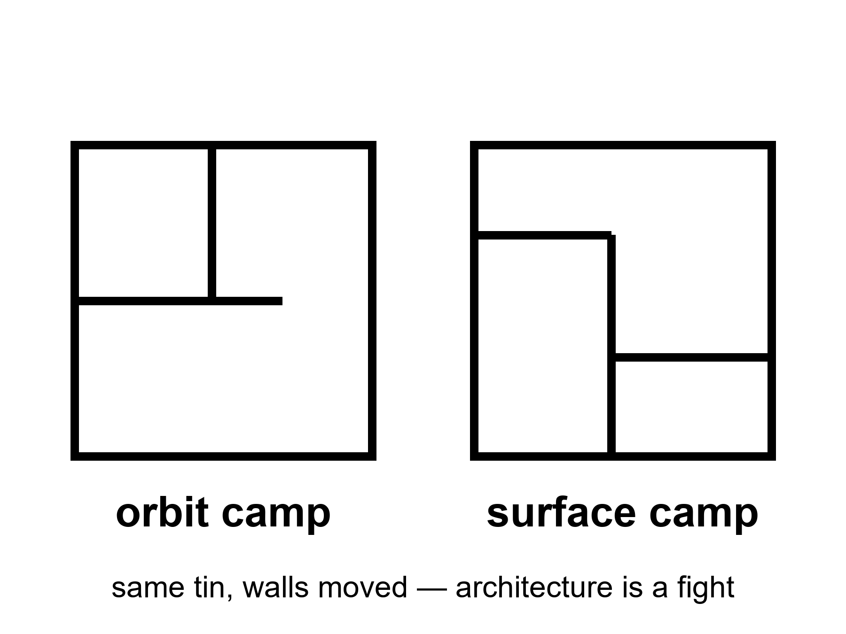
Figure 8. Two floor plans, same dirt: a can in a high odd orbit; a tin on the ground. A fight, not a law.
Gateway, in the American ledger and its partners’ ledgers, is a small station in a near-rectilinear halo orbit — a path that is a compromise between seeing the Moon, seeing Earth, and not spending a fortune every time you want to go down or go home.
where NRHO is a high, lopsided lunar orbit that stays in view of Earth for long stretches and is not “low Moon” in the postcard sense.
A can in that path can be a staging porch: park, refuel, wait, send a lander down, catch a lander up, hide from a solar storm, run a science rack, let a crew sleep somewhere that is not the lander. It can also be a porch you paid for and then found you did not need, if the lander can go from Earth-side to dirt and back without the handshake. That sentence is the fight.
Surface-first people say: every kilogram in the halo can is a kilogram that is not a tin on the ice, not a rover, not a power cable. They say a porch is how you never arrive. Orbit-first people say: every crew that has no porch is a crew with one failure mode away from a very long wait, and a lander that is also a house is a house that must also be a rocket. Both are engineering sentences. Both can be true in different decades. Neither is a law of nature. A law of nature does not issue a contract amendment.
Architecture fights are how you know you are in a program and not a poster. A poster has one floor plan. A program has a graveyard of floor plans and a meeting that is late.
What a station is not.
It is not a town. The International Space Station is the existence proof: a magnificent, expensive, continuously staffed outpost in a well we already own, with a cargo cult from Earth that has never been optional. People have lived there for months. Children have not been raised there as a civilization. The umbilical is the point. Cut the cargo and the outpost becomes a problem, then a wreck. A lunar Gateway would be a smaller, farther, colder cousin of that outpost. Months, if it is lucky. Cargo from Earth. A science rack. A porch. Warm-to-cold as a sustained camp in the 2030s–2040s, because the fight can move a decade and the cargo still has to climb a well.
It is not required by physics. Physics requires a path, a Δv, a place to stand. Physics does not require a particular can in a particular halo. If a later architecture fires the porch and lands from a different path, the porch will have been a choice that was useful or not, like a kitchen island. Kitchen islands are not laws.
It is not a moral. People will try to make it one: we must build the station or we are not a serious species. Seriousness is a habit of invoices. It is not a floor plan.
Nandita Rao drafts the fight for a living. She is invented. She has a wall of versions. Version 3 had a habitat the size of a bus. Version 6 shrank it. Version 8 added a partner’s module that then slipped a year. Version 9 asked whether the landing needed the handshake. She does not hate any version. She hates the sentence “the architecture is settled.” Settled is what you say about a house you are no longer allowed to improve. Camps should not be settled. Camps should be honest about being camps.
Mara does not have a Gateway. She has a tin and a delay. On the delay, someone is still arguing about a porch she will not see. She logs the pH. The argument does not water the tray. The argument might, someday, change whether a person like her has a spare can to run to when the seal fails. That is a real stake. It is still not a city.
Appendix A8 writes NRHO, the porch-versus-dirt fight, and why ISS is an outpost with an umbilical, not a template for a downtown. Here, keep the two floor plans. A fight, not a law.

9. Other Flags, Other Ledgers
China, ILRS, partners: real precursors; a 2030s station is still a camp on paper.
Warm as intent and precursors; cold as a city. Chang’e-class work is hot. A research station named like a destination is still a camp.
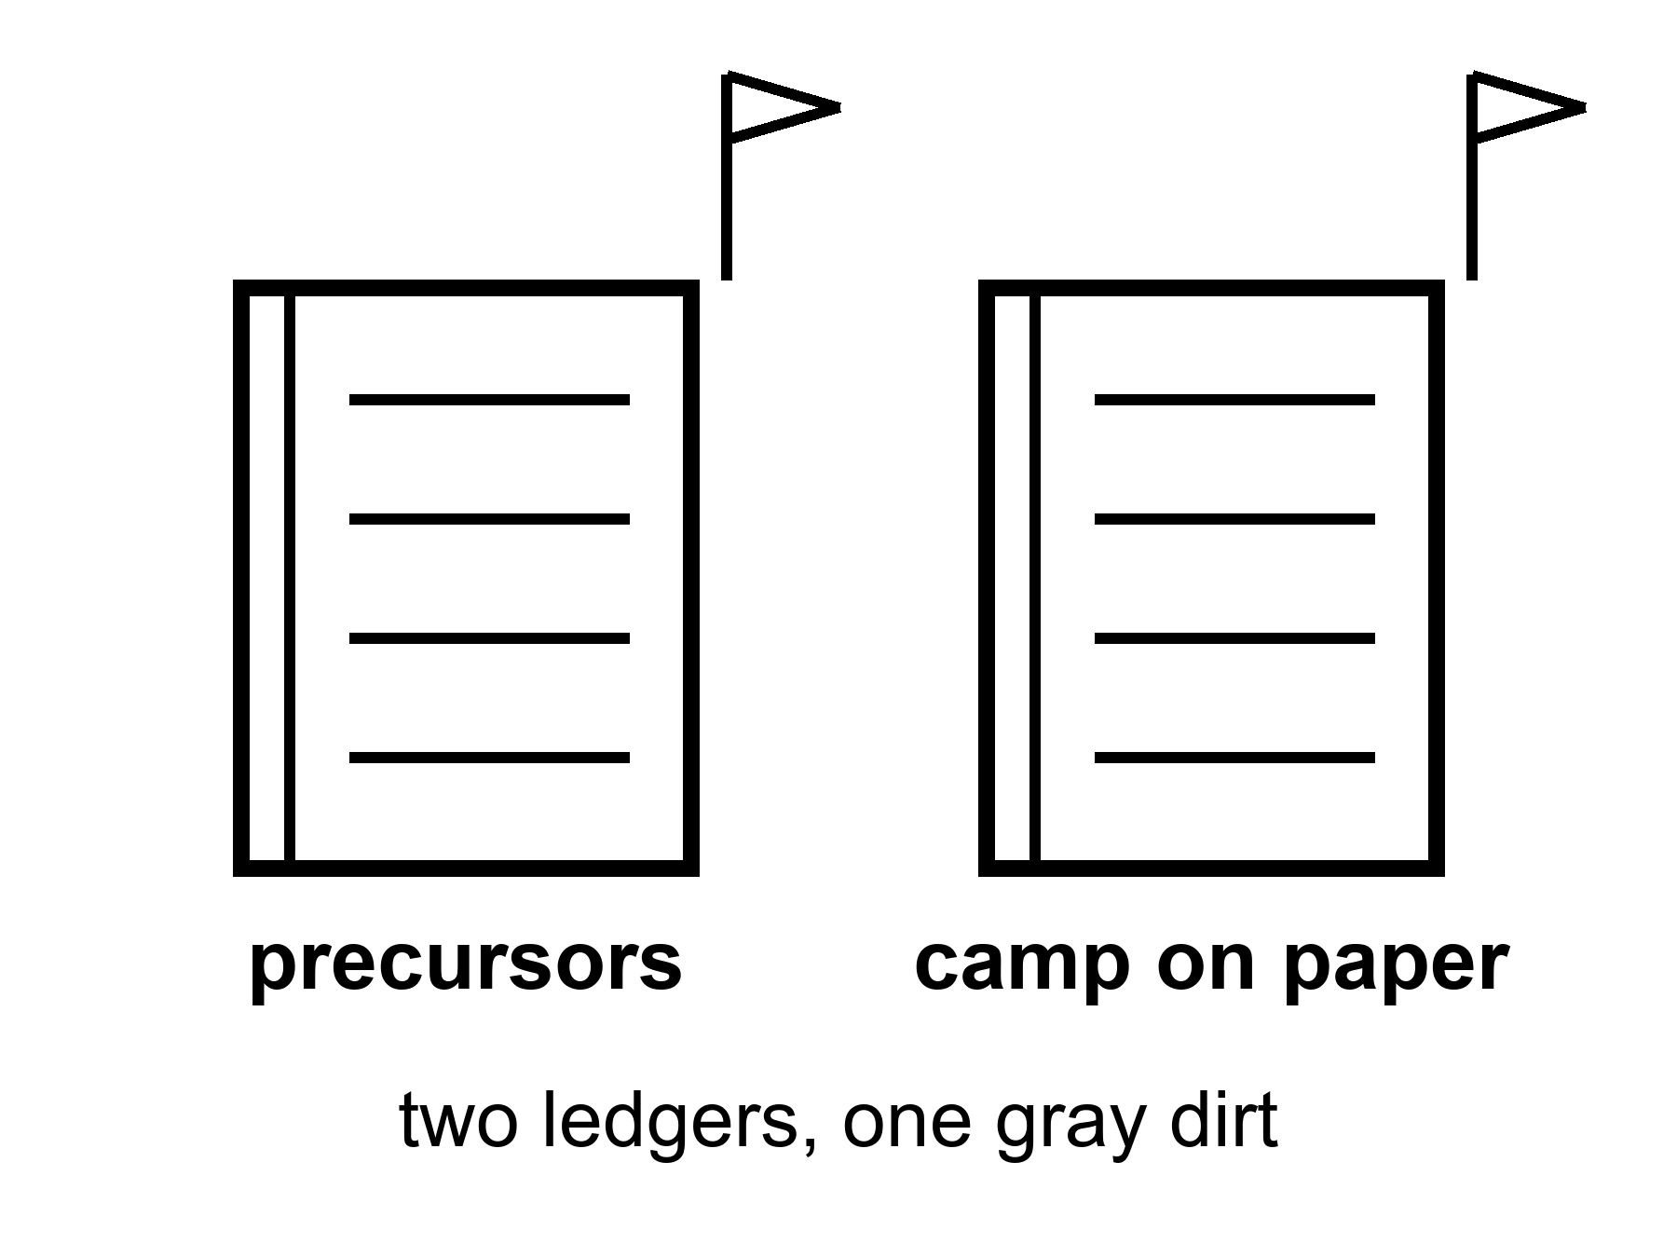
Figure 9. Two ledgers, two flags, one gray dirt. Precursors on the left. A camp on paper on the right.
The American ledger is not the only kitchen.
Chang’e-class landers and sample returns are flown facts, already billed in Chapter 5. Rovers on the familiar face and the far face. A relay satellite that made the far face less of a mute. A plan, with partners, for a camp they name the way you name a station: International Lunar Research Station, ILRS, on paper a 2030s presence at the south, after more precursors — a surveyor, a heavier lander, a cargo trick, a habit of showing up.
Intent is warm. Precursors that have already returned rock are hot. A multinational camp with a name is a drawing. Drawings are allowed. A drawing is not a downtown. A drawing of a research station is, at best, the middle noun: an outpost with an umbilical, weeks to months, cargo from Earth, a science rack, a flag that has company. Company is not a civilization. Company is how you split a cargo bill.
Other ledgers exist and will exist. India has landed and driven. Japan has dared a precision set-down. Europe writes modules and rides. Commercial trucks want a service. A later decade will have more logos on the dirt. More logos is a temperature about access. It is not a temperature about children who do not need a cargo cult.
Two ledgers do not make a city by addition.
People who like races will say the race is the settlement. A race is a reason a legislature pays. It is not a biosphere. Two outposts that cannot feed themselves are two outposts. They can even be useful to each other — a spare pump, a radio, a political reason not to be reckless — and still be camps. The cargo-cult test does not care how many flags are in the photograph. The test is: if the ships from Earth stop, do the babies still eat? Chapter 12 is the test. Here, notice that a second flag is often sold as the moment the first flag became a town. It is the moment the dirt got busier.
Look first, on a rock that never had a biosphere, still means: do not pretend the camp is a spare Earth, and do not treat the Earth you left as already written off because a rival’s slide is prettier this year. The basil does not care which language is on the packet.
Wei Ning is an invented payload scientist in a desert who opened a far-side box and did not sleep. The rock does not belong to a downtown. The rock belongs to a measurement. She will write a paper that makes polar ice a little hotter or a little colder as a tank farm. She will not vote for a skyline. She has seen too many skylines in the hall outside the lab.
On Mara’s delay, a slipped date arrives in a language she does not speak, then in one she does. The date is a camp on paper. She writes it under Earth says, next to the other Earth’s date, which also slipped. She logs the pH. Two ledgers. One tray. The dirt is the same dirt.
Appendix A9 writes Chang’e-class facts, ILRS as a paper camp, and other partners as a list that will rot and be replaced. Here, keep the two ledgers. Precursors are inventory. A name on a station is a wish that has started to buy metal. Metal is not a city.

PART III — Vehicle, Not City

10. Starship as a Vehicle, Not a City
A ship that is large and, one day, cheap per tonne is a vehicle. If Starship-class flight becomes routine — cadence, refuel, a hull that does not make the news every time it lights — the mass you can throw changes. That is warm. Routine is the unpaid invoice.
A vehicle does not print air. A vehicle does not print a law. A vehicle does not print a childhood that can survive the week the cargo does not arrive.
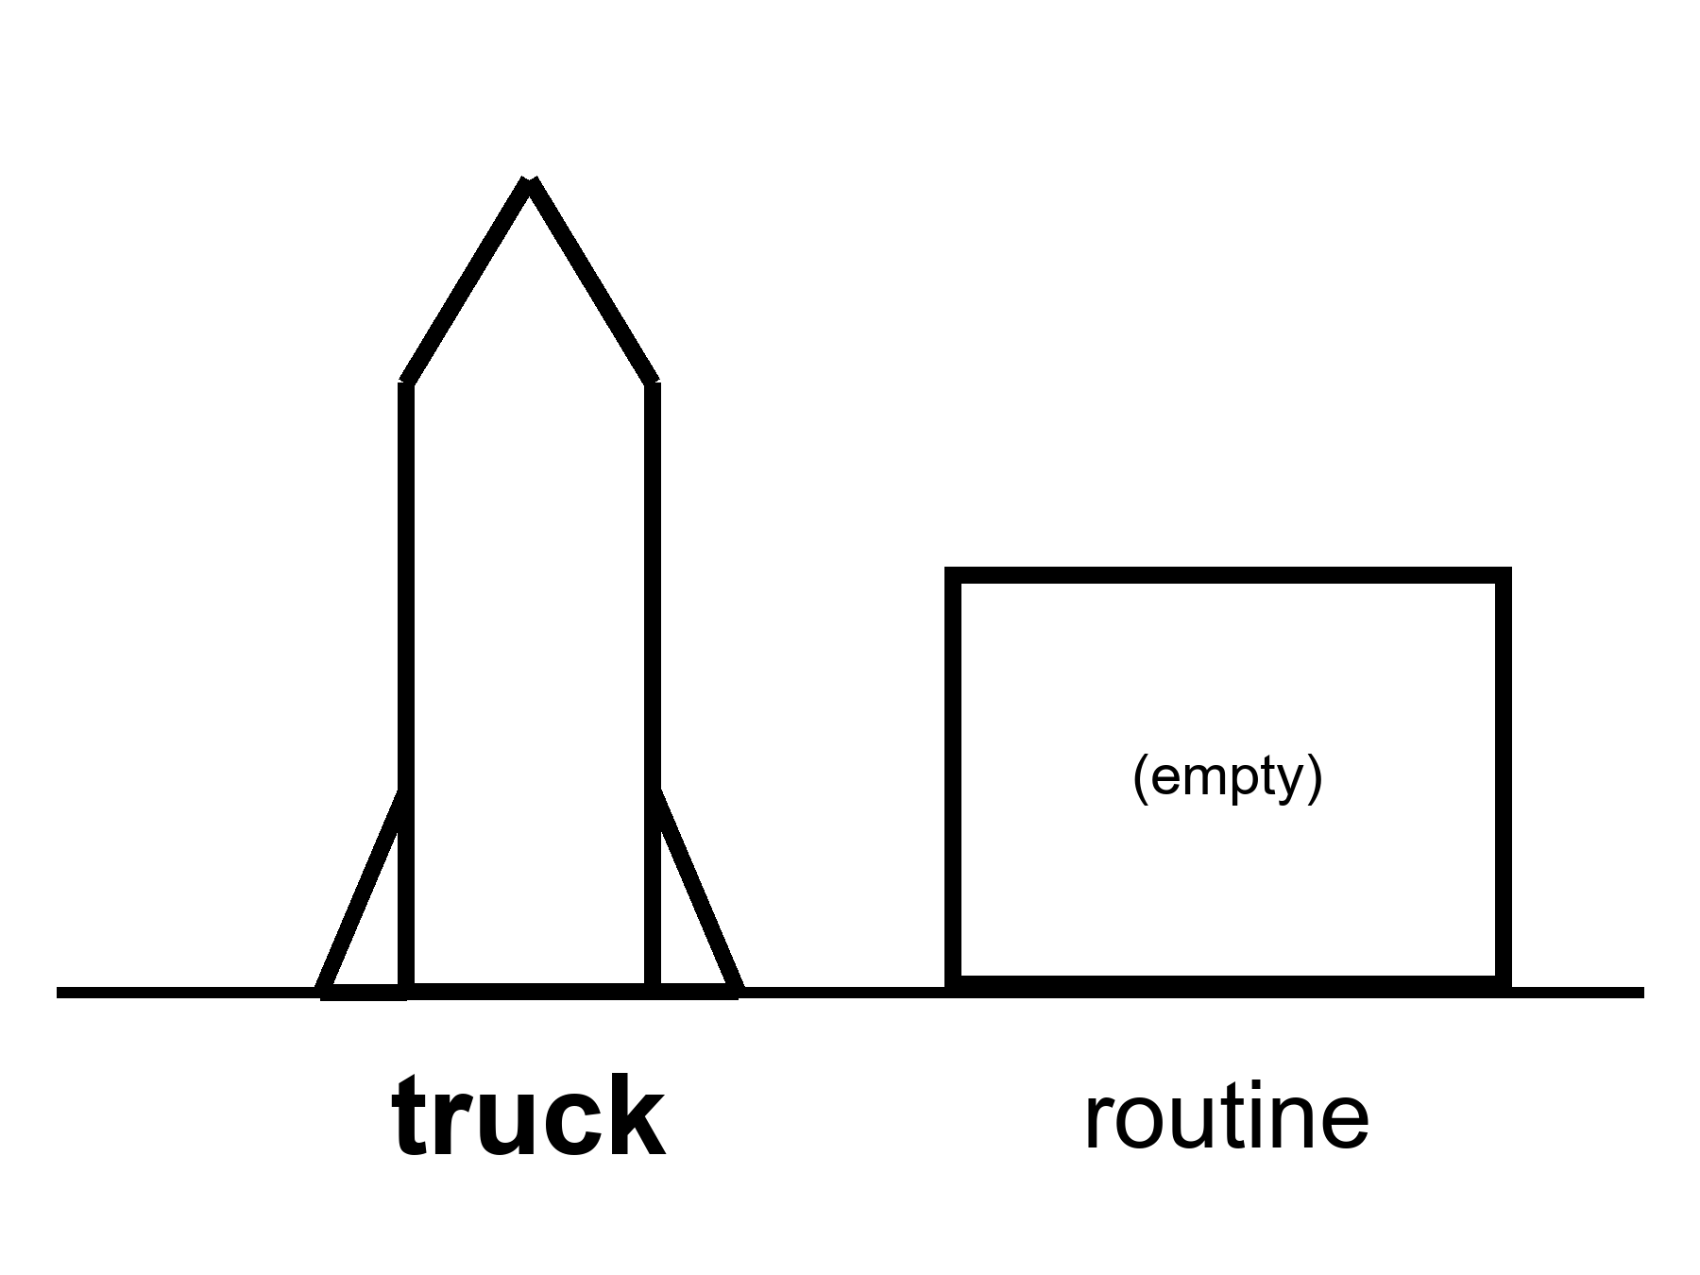
Figure 10. A large hull on a pad, daylight, no skyline. The label: truck. Routine is an empty box beside it.
The eye wants to fuse. A hull the size of a building looks like a building. A building looks like a block. A block looks like a town. The fusion is how a founder’s year becomes a downtown in a single still. Refuse it. Size is a mass budget. A mass budget is a wonderful thing if it is real. It is not a biosphere.
What “cheap per tonne” would actually change, if the unpaid invoice is paid:
You could throw tanks, not thimbles. You could throw a tin that is a room, not a closet. You could throw spare pumps, spare suits, a pile of dirt-moving machines, a nuclear kettle, a greenhouse kit that is not a metaphor. You could, in a lucky decade, throw the first cargo of a camp that is trying to become the middle noun. That is a real increment. It is why this chapter exists instead of a sneer. A species that can throw mass like a drunk trucking company is a different species of project than a species that throws a few tonnes a year and calls each one a jewel.
What it would not change:
The six millibars of excuse on Mars. The last kilometer. The twenty-minute argument. The twenty-six-month sulk if you miss the window. The ice that must be mined, cracked, stored, and not lost to a leak. The dust. The dosimeter. The pH. The fact that a baby is a life-support system with opinions. The fact that a town is a web of invoices — food, law, medicine, boredom, spare parts — that a hull cannot print by being large.
Routine is the word that has to sit still.
where routine means: lights, flies, lands or is caught, is filled again, does this on a calendar that a cargo planner can bet a camp on, and does not make the news every time.
One loud flight is a dare. A dozen loud flights are a test campaign. A hundred quiet flights are the beginning of a truck. We have, in this kitchen, a vehicle class that has lit, flown, broken, taught, and sometimes come back in ways that make a clip. We do not have, as of this writing, the quiet hundred. By the time you read this, the count may be kinder. The temperature of routine should still be earned, not declared. Declaring routine is how a slide cashes an invoice it has not paid.
Refueling is the other unpaid line. A heavy lander or a Mars stack that needs to be filled in orbit is a stack that needs a tanker company, not a tanker occasion. Transferring cryogenic propellant in zero-g without making a fountain or a bomb is a sport. The sport has papers and tests. A camp that depends on the sport cannot print a month that the sport has not yet survived.
Reliability is the third line. A trucking company that loses one hull in twenty is a headline. A trucking company that loses one in twenty when the hull is also a house is a funeral program. The number that would make a planner sleep is ruder than the number that makes a clip.
Dex Ortega writes cadence boards. He is invented. His board has a column for hoped and a column for flown and a column for still on the news. He is tired of people pointing at the hull and saying city. He likes the hull. He likes it the way a person likes a truck that might, if it learns manners, move a house. He will not live in the truck and call the parking lot a town.
Uncrewed Starship on Mars this decade because a founder said the year: cold as a schedule. The vehicle is real and unfinished. Mars EDL, life support, and ISRU are not posters you can cash. A lucky window might take a loud hull on a long fall and try to hit a thin air. That sentence is allowed as a dare. It is not a town. It is not even an outpost. It is a vehicle, thrown, if it is thrown.
Mara hears the clip on the delay — a catch, a light, a cheer in a room she will never sit in. She is glad for Dex, whom she has not met. She logs the pH. The hull did not print the water. The ice did, yesterday, because she and Rohan bullied it.
What a planner actually bets on.
A cargo planner for an outpost does not bet on a clip. She bets on a rate: tonnes per window, windows per decade, losses per hundred lights, days to turn a hull around, whether the tanker company is a company or a dare. If any of those numbers is a wish, the outpost’s kitchen is a wish. ISS planners bet on a cargo cult that has already flown for a generation. They still lose sleep. A lunar or Martian planner who is asked to bet on a hull that still makes the news is being asked to staff a religion.
Mass is not only up-mass. It is down-mass if you want samples, and it is left-mass if you want a tin to stay. Left-mass is the unphotogenic increment a cheap stack would actually buy: a spare, a pile of dirt, a second pump, a kettle. Left-mass is how an outpost stops being a jewelry box. It is still not how a settlement starts. Settlement is closed loops, not a fatter umbilical. A fatter umbilical is a better outpost. Say so. Do not say city.
Dex’s board has started a column called quiet. Quiet means the flight was not a headline. He has very few marks in it. He wants more. He will not trade the marks for a skyline. The skyline can wait until the column is boring.
Appendix A10 writes mass, cadence, and why “cheap per tonne” is a conditional with three unpaid clauses. Here, keep the truck and the empty box. The box is labeled routine. It is still empty until a planner can bet a camp on it.

11. Mars Rhetoric vs Mars Engineering
Mars is where the posters go to breed.
Rhetoric is a decade, a founder, a child in a dome, a species that has become a two-world insurance policy. Engineering is a thin air, a fast arrival, a kitchen you have not built, a radio that is not a conversation, a window that is a fact about two orbits.
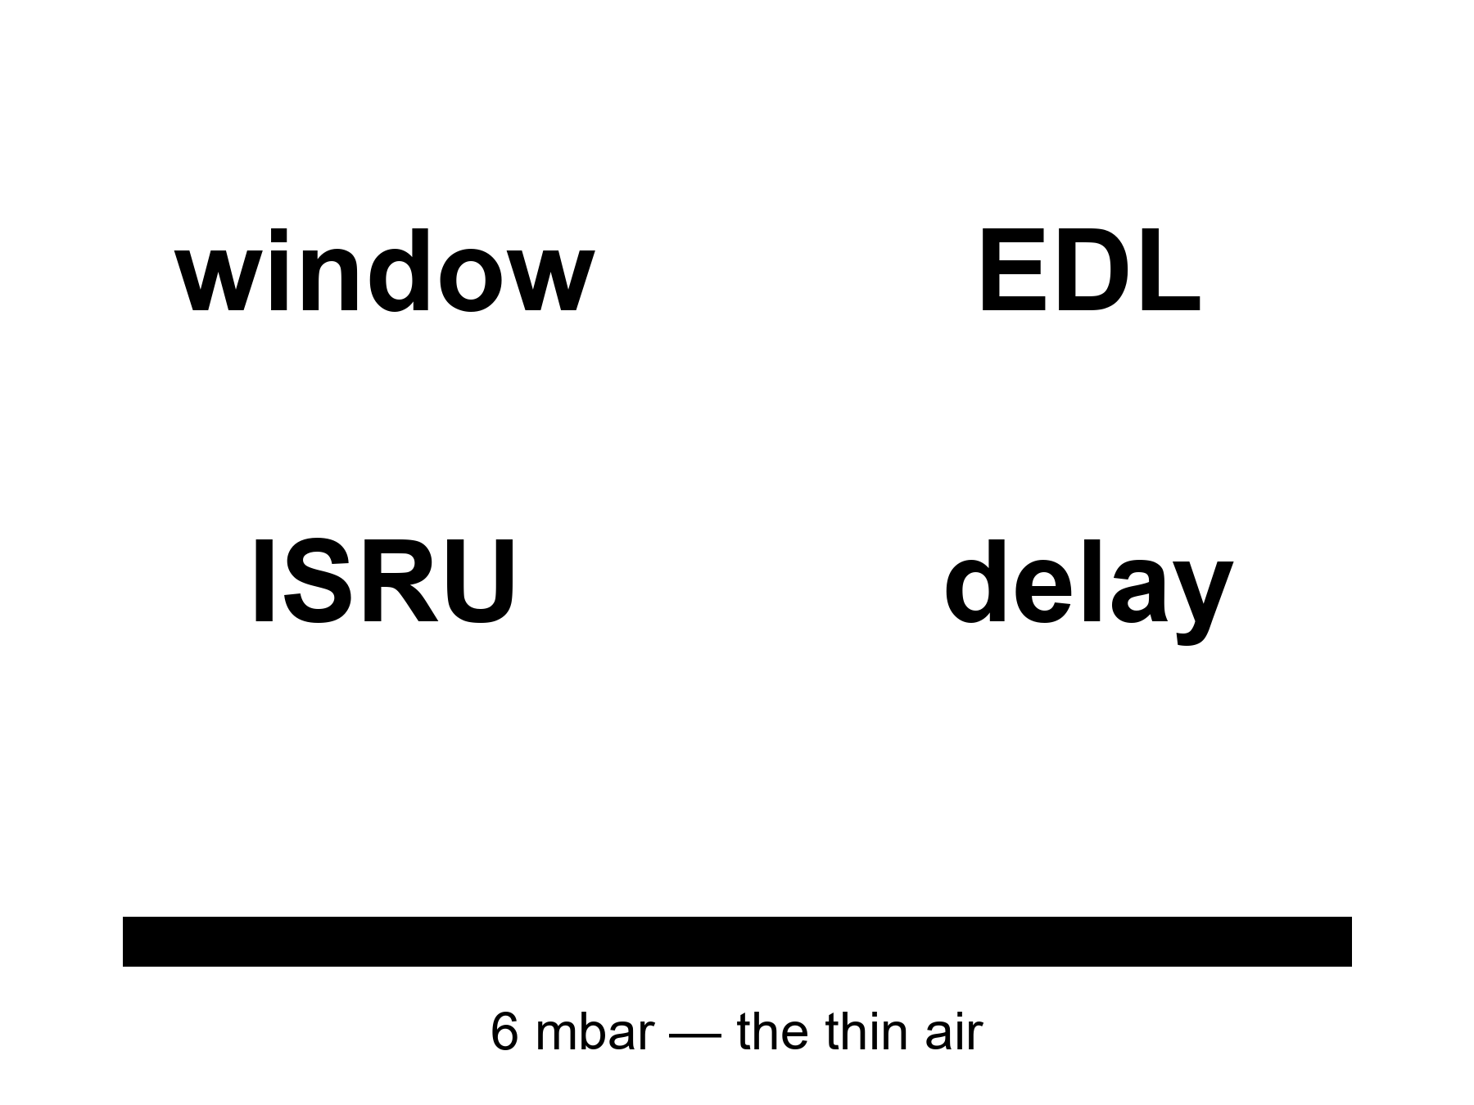
Figure 11. Four large nouns: window, EDL, ISRU, delay. No skyline. The thin air is a bar at the bottom.
Windows. A cheap path from Earth to Mars is a Hohmann-class fall: you leave when the planets are about to be kind, you coast most of a season, you arrive.
where a Hohmann-class transfer is on the order of six to nine months, and the kind alignment — the synodic clock — repeats about every twenty-six months.
Miss the window and you wait on the clock, not on a mood. There is no “we will leave on Tuesday because the slide is lonely.” There is a season you can buy, then a long sulk. A camp that needs a resupply and misses a window is a camp that has just learned what an umbilical is. Twenty-six months is not a weather delay. It is a second calendar you do not get to vote off.
EDL. Entry, descent, landing. You arrive at a world with an atmosphere that is a rumor by Earth’s standards — about six millibars at the surface, a percent of a percent of what your lungs grew up in — and you arrive fast, because interplanetary falls are fast. You must spend that speed on a heat shield, a parachute that has almost nothing to bite, engines that must finish the job, a crane, a belly flop, a trick that has not yet been demonstrated at the mass of a house. Rovers have done a version of this at the mass of a car, with a decade of nerves and a sky crane that still looks like a dare. A hull the size of a building is not a car. The thin air does not become thicker because the hull is famous.
where six millibars is the order of the surface pressure — a kitchen you cannot breathe, a parachute you can barely hire, a sky that is a lie the color of butterscotch.
ISRU. In-situ resource utilization: melt the ice, crack the carbon dioxide, print a spare, make the oxygen you will need to leave, make the methane if your engines drink that pair. MOXIE-class boxes have already, on a rover, made a breath of oxygen from the air that is mostly CO₂. That is hot as a trick in miniature. It is not a tank farm. A tank farm is power, mass, a mine, a leak policy, a winter, a spare, a person who logs the numbers when the box sulks. Papers and prototypes exist. A city does not.
Delay. Light-time one way is about four minutes at a kind opposition and about twenty at the rude ends.
where the round trip is eight to forty-some minutes, and a conversation is a word you should retire.
You send. You wait. You receive a reply to a problem that has already become a different problem. Surgery, a software panic, a seal, a fight: you own them. Earth owns an archive of advice that arrives late. Mara already lives in this sentence. The posters do not.
Crewed Mars landing in the 2030s: warm-to-cold. Allowed by hopium and by a lucky engineering decade. Not selected by present demonstrated pieces. The pieces we have photographed working are: rovers, a breath of oxygen, orbits, landings at car-mass, a vehicle class that is not yet routine, a species that has not yet walked on the Moon in this century. A lucky decade could stack those into a first foot. A first foot is a sortie. It is not a town.
Uncrewed hardware might be thrown in a lucky window this decade. Cold as a schedule if the reason is a founder’s year. Allowed as a dare if the vehicle earns the window and the EDL at that mass is not a wish. Still not a town.
A city this decade: cold. Children without a cargo cult: cold. “Settlement” as a product you can buy by Friday: cold.
The rhetoric has a few favorite lies that are not quite lies.
Backup world. A backup is a copy that can run the job if the first copy dies. Mars, in the near term, cannot run the job. It cannot feed the species. It cannot take the leftover eight billion. It cannot even take a town without Earth in the inbox. Calling it a backup is how you stop washing the kitchen. Chapter 15 is the funeral of that sentence.
If we can go, we should, because the species must not keep its eggs in one basket. Eggs and baskets are a metaphor that photographs well. A basket that cannot hold the eggs is not a basket. A few thousand worldlines on a dead world are a field trip. They are not an insurance policy for a species.
The engineering is just details. Details is what EDL is. Details is what a six-millibar parachute is. Details is what a twenty-six-month miss is. Rhetoric calls them details when it wants a year. Engineering calls them the job.
Pavel Grun writes EDL sims. He is invented. His sims have killed more crews than a war, on paper, and saved none, on dirt, because the dirt has not yet been asked at this mass. He is not a pessimist. He is a person who has seen the thin air win. He would like the thin air to lose, once, in public, at a mass that matters. He will not call the loss a city.
Mara already knows the delay. She knows the window because her ride home is a window. She logs the pH while a voice on Earth, twenty minutes ago, says a year that is a landing gear. She does not vote. The dirt does not vote. The orbits do not vote. The orbits are the only adults in the room.
Dust on Mars is not lunar glass and is still a personality. It is finer, magnetic in its moods, a thing that coats solar panels and lungs and the last kilometer of a landing that wanted to be tidy. A season-long dust event can turn a power budget into a dare. Opportunity — a rover, a car-mass, a saint of a machine — met a sky that would not clear. A house-mass camp meets the same sky with more to lose.
Power is the quiet long pole the posters draw as a rectangle of gold foil. Gold foil is a rover trick. A tin that wants to melt ice, crack CO₂, run a greenhouse lie, and keep a person from freezing through a dust week wants a nuclear kettle or a farm of panels with a spare and a broom. The kettle has a politics. The farm has a dust. Neither is a skyline.
Pavel will not put a kettle on a slide that also has a child. He will put the kettle on a slide that has a dosimeter and a mass. That is the engineering. The rhetoric will sneak the child back in the hall.
Appendix A11 writes the synodic clock, the Hohmann band, the six millibars, MOXIE-class oxygen, and light-time as a table that is allowed to sit still. Here, keep the four nouns. Window. EDL. ISRU. Delay. No skyline.

12. Three Nouns: Sortie, Outpost, Settlement
Three nouns. Keep them unfused.
Sortie — you go, you work, you come home, or you die on a schedule Earth still owns.
Outpost — you stay a season with an umbilical.
Settlement — the umbilical can fail and the babies still eat.
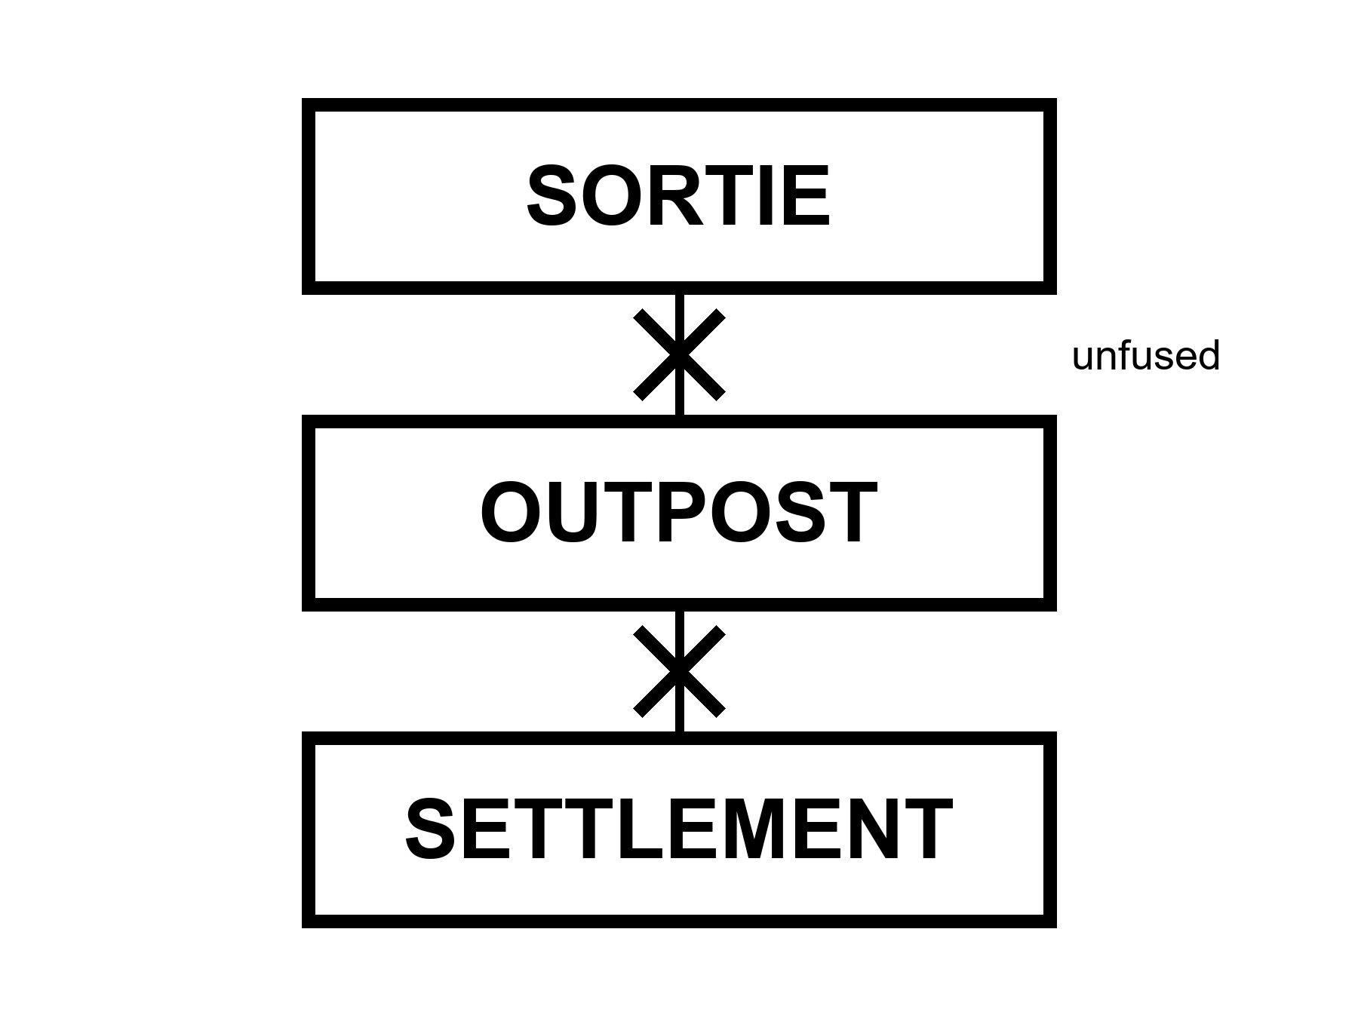
Figure 12. Three large words in a column, unfused. Sortie. Outpost. Settlement. A line through any pair that tries to marry.
This is the meeting-room chapter. The rest of the book has been refusing the marriage in pieces. Here the refusal gets a table and a test.
A sortie is Apollo. A sortie is an Artemis-II-class loop. A sortie is a landing attempt that walks and leaves. A sortie can be heroic, expensive, world-changing as a photograph, and still be a week or a month. The schedule Earth owns is the point. If Earth goes silent, the sortie is already a problem; if Earth stays loud, the sortie was never a civilization.
An outpost is a winter-over, a Gateway season, an ISS-class tin, a polar camp that eats cargo and returns science and rotates crews. The umbilical is the point. Cargo arrives, or the outpost becomes a dare. People can live months. People have lived months in Antarctica, on a station over Earth, in a tin that smelled like a locker. Months are not children. Months are not a farm that closes the loop. Months are the middle noun, and the middle noun is already a magnificent achievement if it is real. It is still not the third.
A settlement is the noun the posters steal. The test is rude and clean. If the ships stop — a war, a budget, a plague, a missed window that becomes a missed decade — do the babies still eat? Not the adults on rations. The babies. A settlement has a closed-enough kitchen: air, water, calories, spare parts, medicine, law, a culture that can teach a child without a download from a dying Earth. No such kitchen exists on the Moon or Mars. No such kitchen is scheduled as a product this decade. Cold.
ISRU is the kitchen word for the middle noun trying to become the third: melt the ice, crack the CO₂, print a spare. Papers and prototypes exist. A city does not.
How the fusion happens in a room.
Someone shows a sortie photograph — a flag, a face, a loop — and says we are a spacefaring civilization. Civilization is a third-noun word. A photograph is a first-noun object.
Someone shows an outpost drawing — a can, a solar farm, a rover — and says the city begins here. Begins is a slide word. An outpost begins an outpost.
Someone shows a hull and says a thousand people. A thousand people is a cruise ship if the umbilical is fat, and a famine if it is not. Headcount is not the test. The test is the babies and the cut cable.
Someone says of course there will be cargo at first. At first is how the third noun is always promised and never billed. A settlement can have trade. Trade is not an umbilical that, if cut, ends the children. Earth’s cities trade. Earth’s cities also grow food in a biosphere that was not shipped last Tuesday. That biosphere is the unpaid character in every Mars downtown.
The cargo-cult test, written so it can sit still.
where a cargo cult, in this book, is a camp whose kitchen is a religion of ships — the ships must come, the calendar of ships is the calendar of life, and the children eat the ships.
Antarctica is an outpost. It has a cargo cult and is honest about it. No one calls McMurdo a spare Earth.
ISS is an outpost. Cut the Progress, the Dragon, the Cygnus, and you have months of rations and then a problem.
A lunar polar camp in the 2030s–2040s, if it exists, will be an outpost. Warm-to-cold as a schedule. Honest if it says so.
A Mars town that cannot close air, water, and calories is an outpost or a sortie with a longer sulk. Calling it a settlement is inventory fraud.
Elena Voss, from Chapter 2, puts the three nouns on the wall of the review and will not let the slide use two in one sentence. She is invented. The wall is a kindness. People who fuse the nouns are not always liars. They are often in a hurry. A hurry is how a flyby becomes a school district. The wall is the school.
Mara is the honest picture of how soon: not never, not downtown, a stuck drawer on a dead world, waiting on a window. She is an outpost of one tin, or two, with an umbilical that is a radio and a ship that has not yet left. She hits the airlock. The basil does not care which logo paid for the LED. She logs the pH. She does not vote for the slide. The universe still does not have an opinion. The dirt does.
A meeting, written so you can steal it.
Elena puts three cards on the table. SORTIE. OUTPOST. SETTLEMENT. She asks the room to point at the hardware on the slide and pick one card. If two fingers twitch, she waits. If someone says “it’s a journey,” she asks them to put the journey down and pick a card. Journeys are how nouns get married in the dark.
The room hates this for twenty minutes and then starts to tell the truth. The loop is a sortie. The polar tin with a cargo calendar is an outpost. The dome with the child is a wish. The hull is a vehicle that might feed the middle noun if routine is paid. Nobody is fired. The slide gets a rewrite. The rewrite is the book’s product: not a cancelled Moon, a refused marriage.
If you run a review and you cannot steal that meeting, you are still in the poster business.
Appendix A12 writes the cargo-cult test as a list of closed loops a settlement would have to show, and why headcount is not one of the loops. Here, keep the three words unfused. If you remember one courtroom from this book, make it this one.

PART IV — Who Stays

13. Who Stays
She hits the airlock and thinks, for a second, of the kitchen she left: a real one, with a clock that lied about Andromeda and told the truth about casseroles. Most of the species is still in that kitchen. They did not buy a ticket. They will not buy a ticket. A camp on a dead world is a staffing choice for a few thousand worldlines, maybe tens of thousands if the posters have a lucky decade. It is not a migration. It is a field trip that forgot to end.
So the question people ask — once we leave, will Earth recover for those who stayed? — has a rude first word. We. Most of us stay.
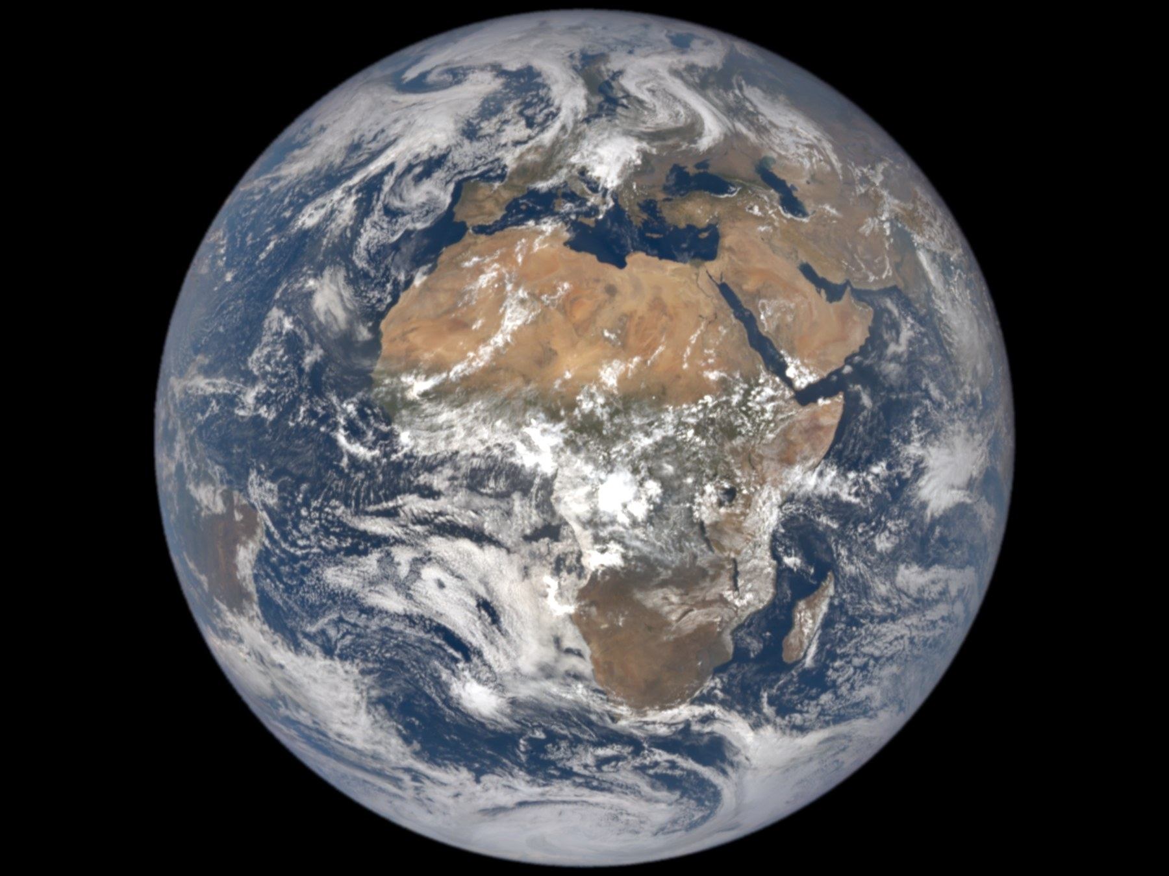
Figure 13. A full Earth, bright, large in frame. A tiny mark for a camp. The staff is the disk.
Credit: NASA/DSCOVR EPIC
Hot: most humans will stay on Earth for any near-term leaving. Launch capacity and tickets are not a species-move. The number of people who have ever been in orbit is a village. The number who have been as far as the Moon is a dinner party, last century. The number who will live a season on Mars in the next two decades, if the lucky decade arrives, is a campus, not a nation. The other eight billion — the number moves, the order of magnitude does not — will still be in the casserole kitchen, opening a real oven, arguing about a real clock.
A ticket is not only money, though money is a filter with a mean streak. A ticket is a body that can take the g, a year that can take the radiation, a nation that will let you go, a program that has a seat, a window that is open, a family that can stand the delay. Most bodies, most years, most nations, most families: stay. That is not a moral. It is a headcount.
Who is “we,” when the slide says we must become a multiplanetary species?
Sometimes it means a company. Sometimes it means a flag. Sometimes it means a species that has been promoted, without a vote, to a passenger list it will never see. The promotion is the rude part. A person in a floodplain, a person in a heat wave, a person whose clinic closed, a person who will never be offered a physical for a stack, is being asked to cheer for a basket that will not hold them. They may still like the photograph. Liking a photograph is allowed. Being drafted into a we that leaves is not a measurement.
Mara’s sister, in the real kitchen, uses we the way the slide uses it. She means: our kind, our cleverness, our backup. She does not mean: I have a boarding time. Mara has a boarding time that is a window home, if the tin still holds. She does not have a species in her pocket.
Rohan’s mother lives in a city that floods in the ugly years. She is invented. The flood is not a metaphor. She asked him, before he left, whether the camp would make the water recede. He told her the truth, which is Chapter 15’s title, and she nodded the way people nod when the truth is not the comfort they paid for. She stays. She is the recovery question. Not the basil. Not the slide. Her street.
A few thousand settlers, even a few tens of thousands, are a town on Earth and a rounding error in a species. They are a large outpost if they exist. They are not a departure of us. The recovery of the kitchen — air, ice, plastics, the dead — is a question about the people who still cook in it. Chapters 14 through 16 are that question. This chapter is the refusal to let the question put on a spacesuit and leave the room.
Look first. The world that already has a staff is this one. The staff is not a remnant. The staff is the species.
Appendix A13 writes launch cadence versus headcount, and why “multiplanetary” in the near term is a camp plus a metaphor. Here, keep the disk. The tiny mark is the camp. The staff is the bright thing.

14. The Clocks of Recovery
Claim, hot: different damages keep different clocks. They do not share a kitchen timer.
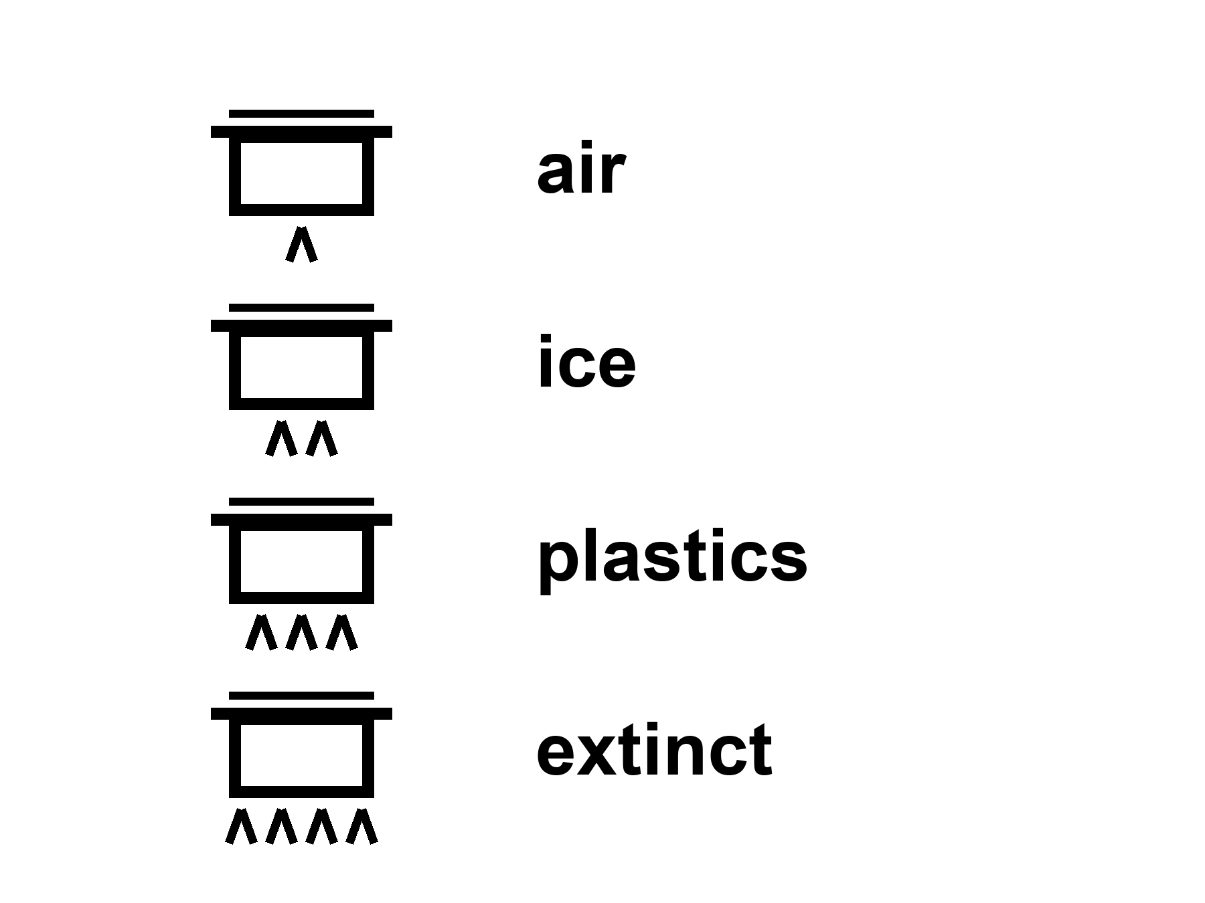
Figure 14. Four pots on a stove, four large labels: air, ice, plastics, extinct. Different flames.
Air. The fastest pot that still pretends to be slow. Carbon dioxide is a well-mixed gas with manners we have measured. A large share of an extra pulse is taken up by oceans and land in decades to a few centuries. A tail stays. The deep ocean and the rocks are ruder; they think in millennia. If you turned every engine off tomorrow, the casserole would not leap back to 1800 by Friday. It would coast. The needle would droop, then linger. A century of burning is not a weekend of weather.
where a pulse of CO₂ is a slug added to the air — and “taken up” means moved into water and wood and soil, not uninvented.
The air also has a faster, ruder guest: methane, which is a stronger blanket per molecule and a shorter career, and aerosols, which are a parasol. The parasol is Chapter 15’s business. Here, keep the pot. Air is the one people mean when they say recover. They mean the needle. The needle is real. It is not the only pot.
Ice. Ice sheets have millennial manners. A melt you earned in a century does not file a resignation because a launch window opened. Greenland and the Antarctic south are not ice cubes in a glass. They are continents of frozen time. They respond to the heat you already put in the well. They can be committed to a loss that arrives after the slide has been forgotten. Mountain glaciers are faster and still not a weekend. Sea ice is faster still, and its death is not the same sentence as a sheet’s death: one is a white lid on a dark ocean, a mirror; the other is a pile that raises the water when it leaves the land. Different clocks. Different invoices.
Plastics. Plastics are not a gas. They are a junk drawer the size of a coast. They do not unmake because the clever apes learned a new hobby. They break into smaller rudenesses. They sit in a gyre, in a bird, in a sediment. You can stop making them. You cannot recall the ones you already threw. A recovery of production is a policy. A recovery of the drawer is a fantasy with a broom. The broom is worth pushing. The drawer will still be there for a career measured in centuries, and fragments after that.
Extinct species. The coldest clock of all: forever, on any clock a person can own. You can grow a forest. You cannot grow a grandmother of a bird you finished. A genome in a freezer is a library, not a grandmother. A library can, in lucky cases, help a cousin. It cannot un-kill a lineage whose last worldline has ended. The longer book already said a library is not a seed unless you look first. Here the sentence is ruder: the dead do not file a return because a camp departed.
Soils, reefs, rivers, a chemical you banned and a chemical you did not. Each has a pot. A soil you mined for a century is not a weekend of cover crop, though the cover crop is worth planting. A reef that cooked is not a weekend of cooler water, though the cooler water is the only kindness left. Persistence is not a sermon. Persistence is a clock. If you want “Earth recovers,” you must say which pot and on whose calendar.
Nadia Okonkwo runs a tide gauge and a patience. She is invented. The gauge is not. She has a plot that does not care about a landing year. She would like the air pot to be less rude for the sister on the coast. She does not need a ship to want that. She needs a furnace policy, a farm policy, a forest that is not a press release. The ship is a different book of invoices.
Mara logs the pH of a tray that is not a biosphere. On the delay, someone asks whether the pots at home will reset when the ambitious have gone. She writes the only sentence that is allowed to be hot about clocks: they do not share a kitchen timer, and they do not care about the ship.
A fifth pot, because people will ask: the water.
Rivers you straightened, aquifers you drank, a wetland you paved. Some of that is a policy you can reverse in a career: a dam you open, a well you stop mining, a floodplain you stop building on. Some of it is a clock with millennial manners: a drained peat that will not be a peat again because you want it to be. Recovery is not one noun. “The environment” is a drawer of pots. If a slide says Earth will recover when we leave, ask it to pick a pot and a calendar. If it cannot, it is selling a garden.
A sixth, ruder pot: the heat already in the well. The ocean has swallowed a share of the extra warmth and will give it back on its own clock. You can stop adding. You cannot un-add Friday. That is why a departure of a camp is not a thermostat even if you pretend the camp was the furnaces, which it is not.
Nadia’s gauge does not argue with any of this. It rises or it does not. It has no opinion about a lander.
Appendix A14 writes the pulse remaining, the ice-sheet manners, the plastic persistence, and extinction as a one-way mark. Here, keep the four pots — and the two extras if you need them. Different flames.

15. Leaving Is Not a Cleanup
Claim, hot: a few thousand settlers do almost nothing to the air. Carbon dioxide does not care that a talented engineer now grows basil under an LED. The thermostat is furnaces, farms, forests, and the habit of turning old sunlight into motion. Remove a village’s worth of passengers and the needle does not bow.
Claim, cold: leaving is a cleanup. It is not. The kitchen you abandoned is still the kitchen. Calling a dead world a spare Earth is a way to stop washing the one you have.
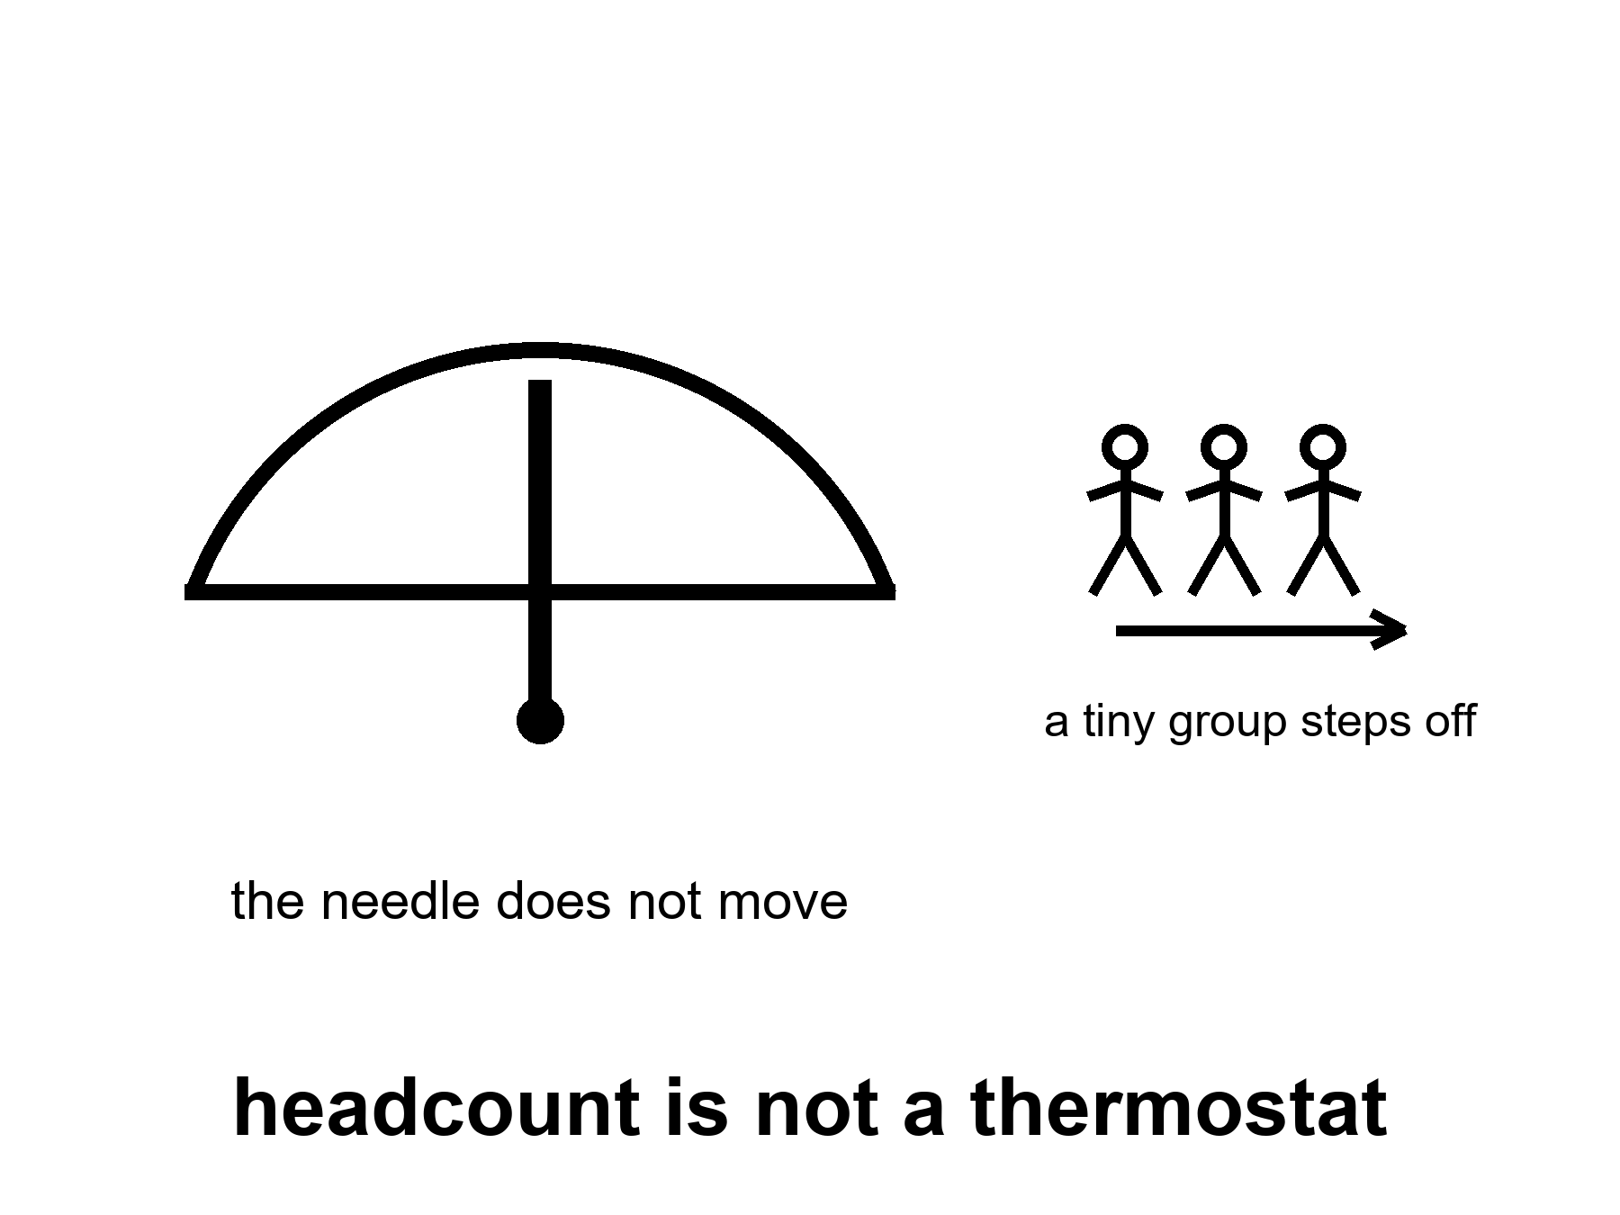
Figure 15. A needle that does not move when a tiny group steps off a scale. The label: headcount is not a thermostat.
Do the arithmetic once, so it can sit still.
A person is not a tonne of carbon. A life is a pattern of energy: a house, a plate, a road, a grid, a state that pours concrete. The pattern varies by zip code more than by virtue. A rich-country life can be on the order of ten-and-more tonnes of CO₂ a year; a poorer life, less; a camp life on a dead world, at first, more, because rockets and life support and printed spare parts are not a monastery. Take ten thousand settlers. Give them, generously, a rich-country footprint and then some. You have a town’s emissions. Global emissions are measured in tens of billions of tonnes a year. The town is a rounding error that might even have the wrong sign if the camp is a construction site.
where the thermostat is industry and land use, not headcount on a ship.
The slide that says if we leave, Earth can heal is doing a swap. It swaps a species-move — which is not on offer — for a camp, and then swaps the camp for a shutdown of the furnaces. The furnaces are not on the ship. The furnaces are in the kitchen that still has the staff.
Claim, warm: if industry collapsed — not a camp departing, but the furnaces going dark — emissions would fall fast. Aerosols would fall too, the bright soot and sulfate that were pretending to be a parasol. The mix is not a simple spring morning. You can lose the parasol before you lose the heat. The casserole can feel, for a while, ruder. Ecosystems would start a different career, not rewind the tape. Collapse is not a cleanup method. It is a different story with its own dead.
This is the paragraph people skip when they want leaving to be a virtue. A virtue that requires a collapse is not a cleanup. It is a famine with a press kit. The dead in that story are not a greenhouse. They are Rohan’s mother’s street, and Nadia’s gauge, and the sister who still says we.
A quieter, hotter fact: you can lower emissions without a collapse and without a camp. That work has a name and a bill and a politics. It is not this book’s manual. This book’s job is to stop the camp from stealing the work’s costume.
Earth “bounces back” as a garden once the clever apes go: cold. The apes are not going. The few who leave do not take the furnaces. The species that stayed would still be the thermostat, or the collapse would be the thermostat, and either way the extinct stay extinct, the plastics stay a drawer, the ice keeps millennial manners, the air coasts. A garden is a staffed thing. A staffed thing is a policy, not a departure.
Mara’s sister asked, in a message that took the long way, whether the planet would be nicer when the ambitious had gone. Mara did not vote. She wrote the only sentence that is allowed to be hot: most of us are still there, and the clocks do not care about the ship.
Appendix A15 writes the settler-versus-emissions arithmetic and the aerosol unmasking as a warm caution, not as a wish for collapse. Here, keep the needle. Headcount on a ship is not a thermostat.

16. The Bill of Going
There is a ruder invoice. The infrastructure of going — the energy, the metals, the cement, the propaganda that this planet is already a write-off — can worsen the bill for the people in the casserole kitchen. Rockets are not a carbon offset. A speech about “backup worlds” is not a climate policy. Look first. The world that already has a staff is this one. Seed later is a rule for a dark sea. It is also a rule for a biosphere you have not finished killing.
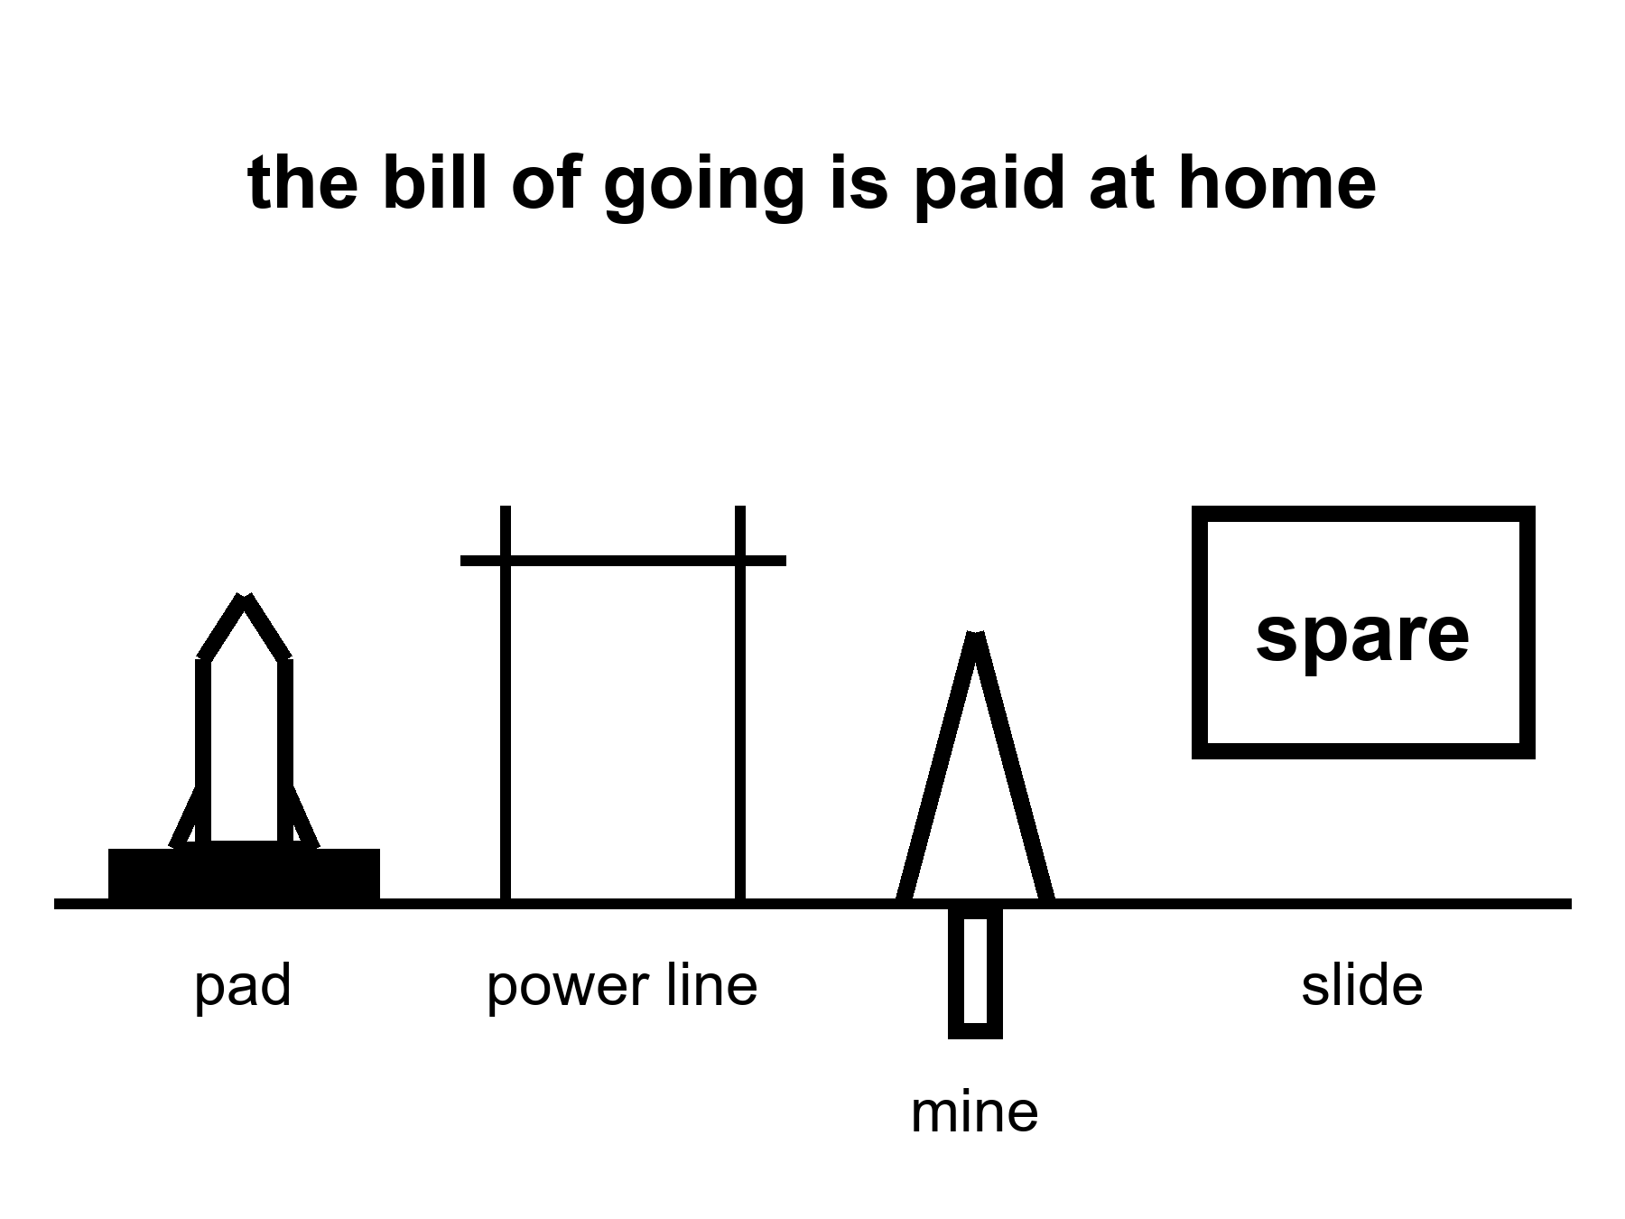
Figure 16. A pad, a power line, a mine, a slide that says spare. The caption: the bill of going is paid at home.
Warm, not a law: spaceflight is not a crime. A rocket is a small line on a global carbon ledger compared with a fleet of coal plants, and a person who sneers at a launch while idling a convoy is running a costume. The honest sentence is smaller and ruder. The industry of leaving, if it scales toward the mass a city would take, is energy, tankers, mines, foundries, pads, a political story that the kitchen is already lost. That story is the warm harm even when the rocket’s own plume is a rounding error. People who believe the kitchen is lost do not vote for the broom. They vote for the dome. The dome is cold. The broom is the work.
Metals and cement are the unphotogenic cousins. A camp that wants to be an outpost wants landing pads, power, pressure vessels, solar or a reactor, a lot of dirt moved. If the dirt is lunar or Martian, that is ISRU and a maybe. If the dirt is Earth’s, that is a mine and a kiln and a ship. Early camps will eat Earth. That is not a scandal. It is an invoice. An invoice that is sold as a carbon offset is a scandal.
Propaganda is a temperature because it moves a vote. Disposable Earth is a phrase that can be a joke and can be a policy. As a policy it is a write-off of Nadia’s gauge and Rohan’s mother’s street. This book will not pretend a joke is harmless once it has a budget.
Honest near term.
A crew around the Moon this decade: warm as a class. A landing attempt in the 2030s: warm. A sustained outpost in the 2030s–2040s: warm-to-cold. A city this decade: cold. Most humans stay: hot. Leaving is not a cleanup: cold. The bill of going can worsen the kitchen: warm. Official dates will slip: hot as a pattern. The orbits will not.
What a finished reader is allowed to keep:
A flyby is not a town. A town is not a cleanup. Most of us stay. The clocks do not share a kitchen timer. A vehicle is not a city. Routine is an unpaid invoice. Three nouns, unfused. Look first on the world that already has a staff.
If you wanted a downtown on Mars by Friday, you should have your money’s worth as hygiene, not as a refund-shaped insult. The basil still has to live. The airlock still sticks. The radio will carry another year. She will not vote for it. She will hit the drawer, and log the pH, and wait on a window that is a fact about two orbits, not a mood.
The universe still does not have an opinion. The dirt does. The dirt at home is the one with a staff. Wash it.
A worked pad, so the rounding error has a face.
A large methane-class launcher burns a few hundred to a few thousand tonnes of propellant on the way up, depending on the stack and the day. Carbon from the methane, and from the grid that made the oxygen and the steel and the concrete, is a number you can write. Write it. Then write a coal plant’s year, or a nation’s year, or a rich city’s year. The pad loses as a villain if the comparison is honest. The pad wins as a villain if the comparison is a sneer at a photograph. Neither comparison is the warm claim. The warm claim is the industry if it scales toward a city: many pads, many tanks, many mines, a politics of write-off. Scale is the word. A science program is not that scale. A downtown-as-product is a request for that scale plus a story that the kitchen is already lost.
Look first, then, has a domestic job. Do not let a camp steal the broom. Do not let a broom steal a camp that is honest about being a camp. Both can be staffed. Both have invoices. Only one of them has eight billion worldlines in it.
Nadia’s gauge, Rohan’s mother’s street, Mara’s sister’s oven: those are the staff. The pad is a tool they may choose to pay for. The slide that says spare is a tool that spends their vote without asking.
Appendix A16 writes rockets on a carbon ledger, mines, and why a write-off is a vote. Here, keep the pad and the slide that says spare. The bill is paid at home.
A later book, if you want it, will keep her hands and refuse helium. You do not need it. You can stop here. The seal will still need the heel of a glove tomorrow.

APPENDIX — The Scientific Detail

How to Read These Notes
Each note An twins popular chapter n. Units are SI unless stated. c is the speed of light. Dates in this kitchen are September 2026; official years will move. Classes of mission are the durable objects.
String theory, if named: a mathematical framework that cannot currently be tested. It is not needed for dirt, delay, or dates.

A0 / A1. Delay, Dirt, and Why a Kitchen Is Not a Loaf
Hot / warm / cold as in the front matter. A claim can change temperature. A stack that has flown is hotter than a rendering. A slipped year is not, by itself, a con.
(1) t = d / c
where t is one-way light-time, d is distance, c ≈ 3.00 × 10⁸ m s⁻¹.
Moon: d ≈ 3.84 × 10⁸ m ⇒ t ≈ 1.28 s (about 1.3 s). Round trip ≈ 2.6 s. A conversation is possible if both ends are patient.
Mars: d runs from about 0.37 AU at a kind opposition to about 2.7 AU when the Sun is in the way of a straight radio path and the planets are far. One-way light-time is about 3–4 minutes at the kind end and about 21–24 minutes at the rude end. Round trip: eight to forty-some minutes. Treat talk as a retired verb.
A loaf — all times on one inventory — is a courtesy from another book. This appendix does not need it. Dirt and delay are local measurements.

A2. What Counts as Flown Hardware
Flown: a vehicle or payload that completed the named job in public, with a serial number and a result (including a failure that still arrived).
This-century lunar inventory, as classes (logos will rot):
• Uncrewed crew-shaped loop and splashdown: Artemis I (2022). Empty seats on purpose.
• Sample return, near side: Chang’e-5 (2020).
• Sample return, far side: Chang’e-6 (2024).
• Soft landing and rover, south polar region: Chandrayaan-3 (2023).
• Precision landing with mixed posture: SLIM (2023–24).
• Commercial landers: mixed stand / tip / quiet. Data, not a downtown.
• Crewed lunar orbit or landing, this century: not flown as of this kitchen.
A rendering, a contract, a clean-room module, a hopped prototype: not flown as the job on the slide.

A3. Slip as Invoice: Historical Pattern
A slip is a moved official date for a named class of mission.
Pattern (not a morality play): Apollo slipped and then walked. Shuttle slipped, flew, then taught a tile-and-wish lesson. Constellation was cancelled as a program, not as a proof that the Moon is unreachable. Artemis-class crew dates have moved in public more than once in the 2020s. Commercial heavy-stack dates have moved in public more than once.
Read a slip as information when it names the long pole (shield, suit, pour, weld, partner can). Read it as fog when it names only “integration.” Fog is not automatically fraud. An empty oven with a roast on the slide is the fraud test.

A4. Three Days, 1.3 Seconds, One-Sixth *g*
Transit Earth–Moon at the speeds we actually use: on the order of three days, not a Hohmann season.
Surface gravity: g_{Moon} ≈ 1.62 m s⁻² ≈ g/6.
Lunar Δv sketch (order of magnitude, not a flight plan):
(3) LEO → TLI ~ 3.1–3.2 km s⁻¹; lunar orbit capture and landing add several more; Earth return is a heat-shield problem as much as a propellant problem.
Polar ice: permanently shadowed craters show hydrogen signatures consistent with water ice in useful-if-true amounts. Useful-if-true is not a tank farm. ISRU from that ice is a middle-noun program.

A5. Uncrewed Loops, Landers, Sample Returns
Loop ≠ landing ≠ return ≠ shift.
A loop tests stack, guidance, and Earth entry. A landing tests the last kilometer in a vacuum well. A return tests ascent, rendezvous or direct throw, and a second entry. A shift is a roster that repeats. This century has loops, landings, and returns. It has machine shifts beginning. It has not had a human winter-over on the Moon.

A6. Artemis-II-Class: Sortie, Not Town
Class of mission: crew in a cabin on a cis-lunar loop, home in days if the stack behaves. Warm as a this decade class. The exact month is a mood.
What it must demonstrate: life support with breath in it, crew operations, comms, entry with people. What it is not asked to demonstrate: landing, ISRU, a town, a child.
If the morning has already happened when you read this, you own a flown sortie. You still do not own a settlement.

A7. HLS / Starship-Class Long Poles
Human Landing System class: a cabin that goes down and is supposed to come up.
Long poles:
1. Orbital refueling if the architecture pours (cryogenic transfer, many times). 2. Last kilometer: no air, dust, throttle, slope. 3. Ascent / leave and meeting the home cabin. 4. Suits as workplaces in glass dust. 5. Power, abort, medical, polar night if that is the site.
Landing attempt in the 2030s: warm. “Attempt” is the honest noun.

A8. NRHO, Stations, and Floor Plans
(NRHO) near-rectilinear halo orbit: a high, lopsided lunar path with long Earth view. A porch, not a law.
ISS is the existence proof of a continuously staffed outpost with a cargo cult that has never been optional. Gateway-class is a smaller, farther cousin on paper. Architecture fights (porch vs surface-first) can move a decade. Warm-to-cold as a 2030s–2040s winter-over.

A9. Chang’e-Class, ILRS, Partner Camps
Chang’e-5 / 6 sample returns: hot as flown. ILRS as a 2030s multinational research station: warm as intent and precursors; cold as a city. Other ledgers (India, Japan, Europe, commercial trucks) change access, not the cargo-cult test.
Two outposts are two outposts. Addition of flags is not closure of air, water, and calories.

A10. Mass, Cadence, and the Unpaid Routine
Cheap per tonne is conditional on routine.
where routine means lights, flies, is refilled, repeats on a planner’s calendar, and does not make the news every time.
Refuel campaigns ≠ one pour. Reliability for a hull that is also a house is a funeral statistic until the rate is boring.
Uncrewed Mars this decade because a founder named a year: cold as a schedule. Vehicle class changing mass if routine: warm.

A11. Windows, EDL, ISRU, Light-Time
(2) Hohmann-class Earth–Mars: ~6–9 months. Synodic repeat: ~26 months (about 2.14 years).
Mars surface pressure: order 6 mbar (0.6 kPa), ~0.6% of Earth’s sea-level 1013 mbar. Parachutes are underemployed. EDL at house-mass is not rover-mass.
MOXIE-class: a box on a rover made grams-per-hour of O₂ from CO₂. Hot as a trick in miniature. Not a tank farm.
Light-time: see (1) and A1. Crewed Mars landing in the 2030s: warm-to-cold. City this decade: cold.

A12. The Cargo-Cult Test
(8) A settlement test: if ships from Earth stop, do the babies still eat?
Closed-enough loops to show: air, water, calories, spare parts, medicine, law, teaching. Headcount is not a loop. ISS and Antarctic stations fail the test on purpose and are honest outposts.
ISRU is the middle noun trying to become the third. Papers exist. A city does not.

A13. Headcount, Tickets, and Why “We” Is Rude
People ever in orbit: a village. People on the Moon: a last-century dinner party. Near-term Mars seasons, if a lucky decade arrives: a campus, not a nation. Species headcount: order 8 × 10⁹.
Launch cadence and tickets are not a species-move. “We left” is a grammar error unless the referent is a camp.

A14. Air, Ice, Plastics, Extinction
(6) An extra CO₂ pulse: a large share taken up by ocean and land in decades to a few centuries; a tail in the deep ocean and rocks over millennia. Not a weekend reset to 1800.
Ice sheets: committed response on centuries–millennia. Mountain glaciers faster; sea ice faster still and a different invoice (albedo vs sea-level).
Plastics: persistent solids; fragmentation, not resignation. Production can stop; the drawer remains.
Extinction: one-way on any human clock. A freezer genome is a library, not a grandmother.

A15. Settlers vs CO₂; Collapse vs Cleanup
(7) Order-of-magnitude: 10⁴ settlers × ~10 t CO₂e/person-year ≈ 10⁵ t/year. Global fossil-and-industry emissions: order 3–4 × 10¹⁰ t/year. The camp is a rounding error and may have the wrong sign if it is a construction site.
The thermostat is industry and land, not headcount on a ship.
If industry collapsed: emissions fall fast; sulfate/soot parasol falls too; short-term unmasking of heat is a warm caution. Collapse is not a cleanup method.
Leaving as cleanup: cold.

A16. Rockets, Metals, and the World with a Staff
A single launch is a small line on a global carbon ledger next to a coal fleet. A scaled industry of leaving (energy, mines, cement, pads) plus a write-off story (Earth is already lost) can worsen the bill for those who stay. Warm, not a law that spaceflight is a crime.
Rockets are not a carbon offset. Backup-world talk is not a climate policy.

Equations at a Glance
# | Relation | Role
(1) | t = d/c | Light-time
(2) | Hohmann ~6–9 mo; synodic ~26 mo | Mars clocks
(3) | Lunar Δv sketch | Why the Moon is the test kitchen
(4) | ~6 mbar | Mars air as a rumor
(5) | MOXIE-class grams/hour | ISRU miniature
(6) | CO₂ pulse remaining | Air pot
(7) | Settler × footprint ≪ global | Headcount ≠ thermostat
(8) | Babies eat if ships stop? | Settlement test

Further Reading (tiered)
Start here: a current public NASA/Artemis status page (years move); a Chang’e sample-return paper; any honest treatment of Mars EDL at increasing mass.
Earth clocks: IPCC-class carbon-cycle chapters; ice-sheet reviews; plastic-persistence reviews; extinction as a one-way mark.
Avoid as engineering: a downtown dated this decade; leaving as a cleanup; a founder’s year as a landing gear.

Glossary
Sortie. Go, work, come home — or die on a schedule Earth still owns.
Outpost. A season with an umbilical.
Settlement. The umbilical can fail and the babies still eat.
ISRU. Make the kitchen there. Not a city charter.
Slip. A moved official date. Invoice, not destiny, not automatically fraud.
Window. An alignment you do not vote off.

